Exploring Powers of 10
Writes a power of 10 greater than  1 in exponent form  10 000 000 = 10⁷  (the number of zeros is equal to the exponent) | Uses a place-value chart to multiply a decimal by a power of 10 greater than 1  0.032 × 10⁴  In the chart, move each digit 1 place to the left for each multiplication  by 10.  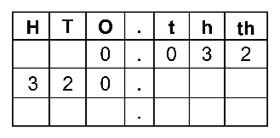  0.032 × 10⁴ = 320 | Writes a power of 10 between 0 and 1 in exponent form  0.000 001 = 10^{–6}  (the number of zeros, including the initial zero, is equal to the negative exponent) | Uses a place-value chart to multiply a decimal by a power of 10 between 0 and 1  5.6 × 10^{–3}  In the chart, move each digit 1 place to the right for each division by 10.  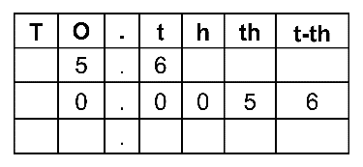  5.6 × 10^{–3} = 0.0056
Observations/Documentation

