Solving Problems Involving Composite 3-D Objects
Decomposes a composite object into known objects  The house (without the chimney)  is made up of a rectangular prism and a triangular prism. | Applies decomposition to determine the volume of a composite object  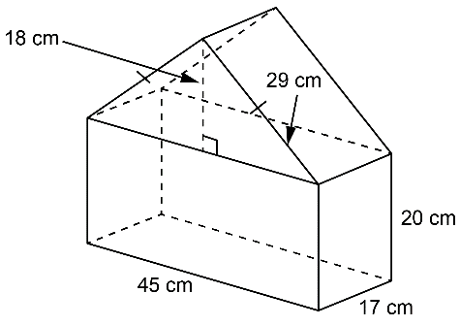  Volume of rectangular prism:  45 × 17 × 20 = 15 300  Volume of triangular prism:  (45 × 18 ÷ 2) × 17 = 6885  Volume of composite object:  15 300 cm³ + 6885 cm³  = 22 185 cm³ | Applies decomposition to determine the surface area of a composite object  Surface area of rectangular prism:  45 × 17 + 2(45 × 20) + 2(17 × 20)  = 3245  Surface area of triangular prism:  2(45 × 18 ÷ 2) + 2(29 × 17) = 1796  Surface area of composite object:  3245 cm² + 1796 cm² = 5041 cm² | Solves problems involving surface area or volume of composite objects  A pastry chef is creating a cake  in the shape of a cylinder on top  of a rectangular prism. What is the volume of the cake?  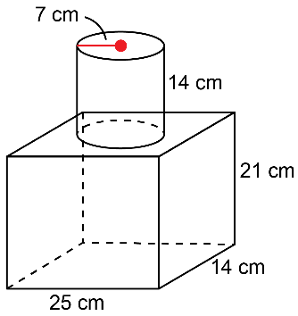  Volume of rectangular prism:  25 × 14 × 21 = 7350  Volume of cylinder:  ($π$ × 7 × 7) × 14 ≈ 2154.04  Volume of cake:  7350 cm³ + 2154.04 cm³  = 9504.04 cm³

Observations/Documentation

