Building Objects from Drawings
Identifies 3-D objects from their top, front, and side views  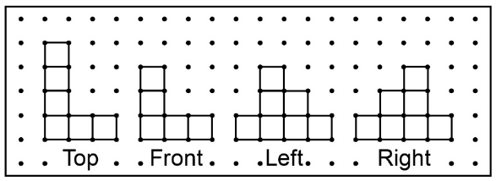  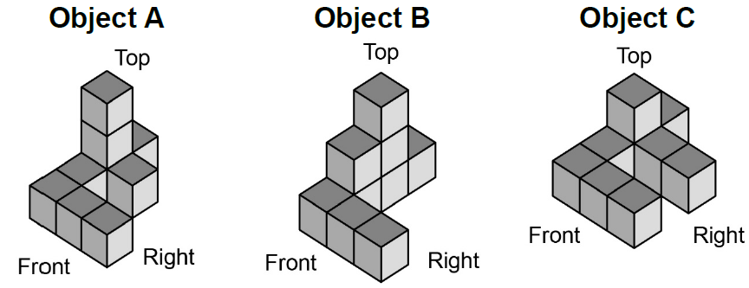  “The views match Object B.” | Builds 3-D objects from their top, front, and side views  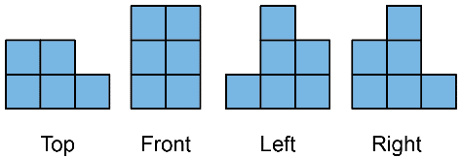  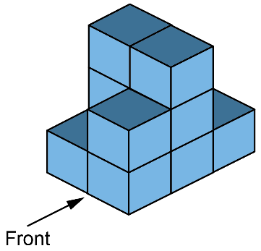 | Builds 3-D objects from their perspective drawing  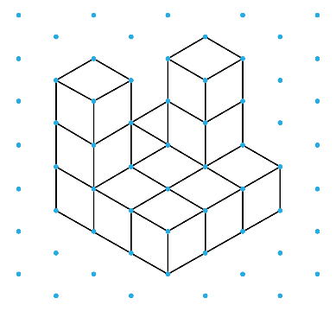  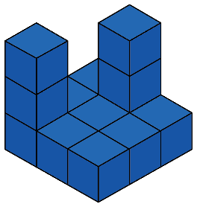 | Builds 3-D objects using appropriate scales  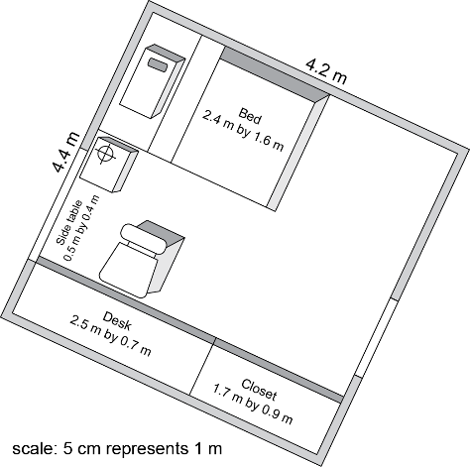
Observations/Documentation

