Exploring Tessellations
Recognizes tessellations  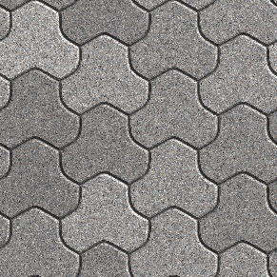  Same shape is repeated. It covers a surface with no gaps between them. | Identifies properties of tessellating shapes  A regular polygon will tesselate if 360° divided by the measure of  each interior angle is a whole number. For example, the sum  of the interior angles of a square  is 360°.  360° ÷ 90° = 4 | Identifies the tessellating tile used to create a tessellation  The tessellating tile is composed of a square and 2 equilateral triangles. | Identifies the transformations used to create a tessellation  Reflect the tile vertically in a horizontal line of reflection passing through the bottom right corner of the square. Then translate the shape right and up.
Observations/Documentation

