Transformations on the Cartesian Plane
Describes translations, reflections, and rotations about the origin on a Cartesian plane using mapping rules  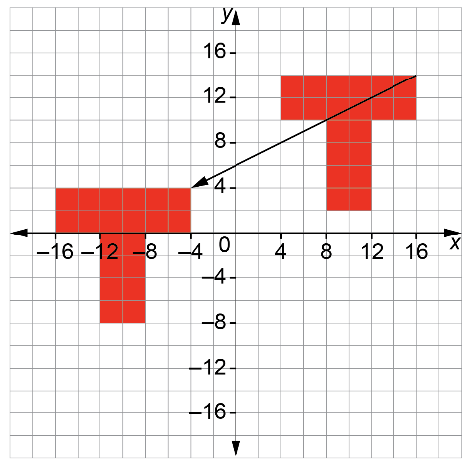  (x, y) → (x – 20, y – 10) | Describes dilations about the origin on a Cartesian plane using mapping rules  Vertices of initial shape:  (–2, 2), (–2, –6), (6, –6), and (6, 2).  Vertices of image:  (–1, 1), (–1, –3), (3, –3), and (3, 1).  (x, y) → (0.5x, 0.5y) | Performs and describes combinations of transformations  Triangle A is reflected in the y-axis and translated left 2 and down 5.  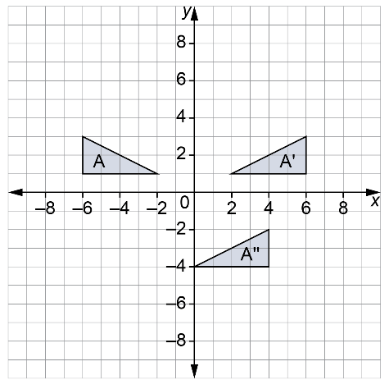  (x, y) → (–x, y) then  (x, y) → (x – 2, y – 5)  Or (x, y) → (–x – 2, y – 5) | Predicts the result of combinations of transformations  Triangle A with vertices at (–2, 1),  (–6, 1), and (–6, 3) is dilated by a scale factor of 2 and translated left 2 and down 5.  Dilation: (x, y) → (2x, 2y)  Translation: (x, y) → (x – 2, y – 5)  Or, (x, y) → (2x – 2, 2y – 5)
Observations/Documentation

