Solving Problems with 2-D Composite Shapes
Decomposes a composite shape into known shapes  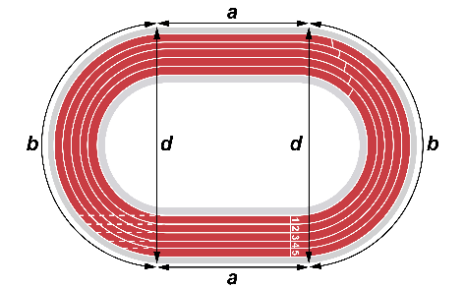  The track is made up of a rectangle and two half circles. | Applies decomposition to determine the perimeter of a composite shape  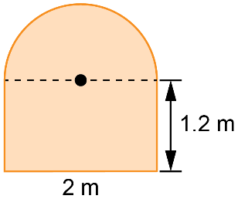  Perimeter of rectangle portion:  1.2 m + 2 m + 1.2 m = 4.4 m  Perimeter of half circle portion:  (π × 2 m) ÷ 2 ≈ 3.14 m  Perimeter of composite shape:  4.4 m + 3.14 m = 7.54 m | Applies decomposition to determine the area of a composite shape  Area of rectangle:  1.2 m × 2 m = 2.4 m²  Area of half circle:  (π × 1 m × 1 m) ÷ 2 ≈ 1.57 m²  Area of composite shape:  2.4 m² + 1.57 m² = 3.97 m² | Solves problems involving perimeter and area of composite shapes  Determine the perimeter and area  of the garden.  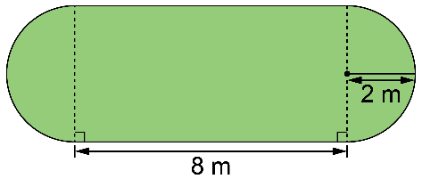  Perimeter: circumference of circle + 2 sides of rectangle  = (2 × π × 2) + 2 × 8  ≈ 28.56  The perimeter is about 28.56 m.  Area: circle + rectangle  = (π × 2 × 2) + 8 × 4  ≈ 44.56  The area is about 44.56 m².
Observations/Documentation

