Exploring Angle Properties
Identifies types of angles formed by parallel lines and a transversal  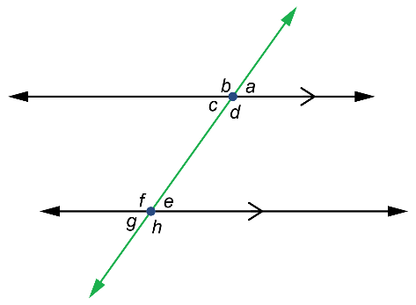  Alternate angles: c and e, d and f  Corresponding angles: a and e,  b and f, c and g, and d and h  Interior angles: c and f, d and e | Uses properties of parallel lines and transversal to determine angle measures  Determine the measure of angle x.  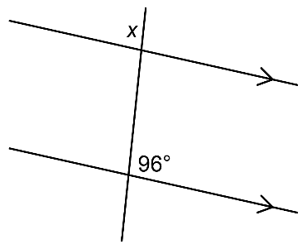  The alternate angle is 96°, which is the supplementary angle to x.  So, angle x is 180° – 96°, or 84°. | Uses properties of similar shapes to determine angle measures  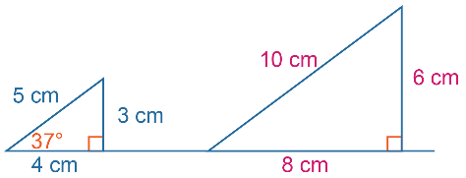  These triangles are similar because the corresponding sides are proportional with scale factor 2.  So, corresponding angles will be equal. Small triangle: the unknown angle measure is 53° because interior angles of triangle add to 180°. | Uses angle properties to determine angle measures  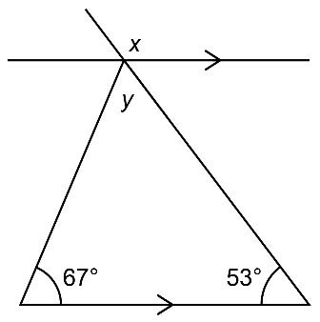  y = 60°; sum of interior angles  of triangle add to 180°  x = 127°; alternate angle is 53°, which is supplementary angle to angle x
Observations/Documentation

