Using Scale Drawings
Understands scale on a scale drawing  The scale is the ratio of a length in the drawing to the corresponding length in the actual object. For example, if a scale measurement of 5 cm represents an actual measurement of 35 m, then the scale is 1 cm : 7 m. The scale drawing and the shape of the actual object are similar. | Uses a scale to determine actual dimensions  On the scale drawing, the length of a building is 15 cm. The scale of the drawing is 1 cm = 2 m. Determine the actual length of the building.  1 cm = 2 m. The scale factor is 2.  15 × 2 = 30  So, 15 cm is equivalent to 30 m.  The actual length of the building  is 30 m. | Creates a scale drawing given a scale  1 cm = 2 m  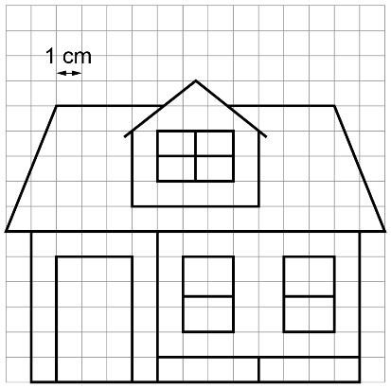  For example, the actual length was 30 m. So, the scale measurement is 30 ÷ 2, or 15 cm. | Solves problems using scale drawings  In a scale drawing, a rectangular classroom is 18 cm by 24 cm. If the scale is 1 cm = 0.5 m, what is the area of the room?  The area of the scale drawing is  18 cm × 24 cm = 432 cm².  Convert to square metres.  1 cm = 0.5 m, so the scale factor  is 0.5. Then, (1 cm)² = (0.5 m)²,  or 0.25 m². The scale factor is 0.25.  432 × 0.25 = 108  The area of the room is 108 m².
Observations/Documentation

