Solving Problems with the Pythagorean Relationship
Describes how to use the Pythagorean relationship  I can substitute the known side lengths into a² + b² = c², where a and b are the lengths of the shorter sides and c is the length of hypotenuse, to find the unknown length in a right triangle. | Uses the Pythagorean relationship to determine an unknown side length  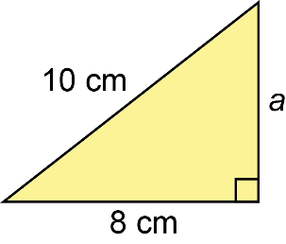  a² + b² = c²  a ² + 8² = 10²  a ² + 64 = 100  a² = 100 – 64  a² = 36  a = $\sqrt{36}$  a = 6  The unknown side length is 6 cm. | Identifies a right triangle in a real-life situation  A gameboard is a square with sides  40.8 cm. What is the length of the diagonal across the gameboard?  Draw a diagram.  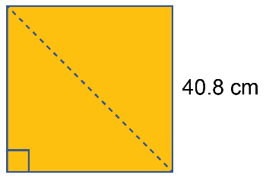  a² + b² = c²  40.8² + 40.8² = c²  1664.64 + 1664.64 = c²  c² = 3329.28  c = $\sqrt{3329.28}$  c ≈ 57.7  The length of the gameboard diagonal is about 57.7 cm. | Uses the Pythagorean relationship to solve problems involving an unknown side length in a right triangle  The horizontal distance from a surveyor to the base of a cliff is measured to be 150 m. The distance from the surveyor to the top of the cliff is 188 m. What is the height  of the cliff?  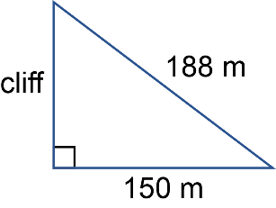  a² + b² = c²  a ² + 150² = 188²  a ² + 22 500 = 35 344  a² = 35 344 – 22 500  a² = 12 844  a = $\sqrt{12 844}$  a ≈ 113.33  The height of the cliff is  about 113.33 m.

Observations/Documentation

