Exploring Relationships in Right Triangles
Identifies hypotenuse of a right triangle  The hypotenuse is the longest side of a right triangle and is opposite the 90° angle. | Describes the Pythagorean relationship  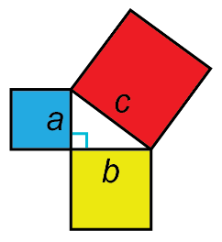  a² + b² = c²  In a right triangle, the sum of the areas of the two smaller squares equals the area of the larger square. | Applies the Pythagorean relationship to determine the length of the hypotenuse of a right triangle  Determine the length of the hypotenuse.  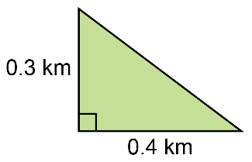  a² + b² = c²  0.3² + 0.4² = c²  0.09 + 0.16 = c²  c² = 0.25  c = 0.5  The hypotenuse is 0.5 km. | Identifies a problem involving the application of the Pythagorean relationship and uses the relationship to find an unknown hypotenuse  A top of a slide is 6 m above the ground and the base of the slide is 4.5 m along the ground. How long is the slide?  The length of the slide represents the hypotenuse of a right triangle.  I can use the Pythagorean relationship.  a² + b² = c²  6² + 4.5² = c²  36 + 20.25 = c²  c² = 56.25  c = $\sqrt{56.25}$  c = 7.5  The slide is 7.5 m long.
Observations/Documentation

