Exploring Angles in Polygons
Measurement
Unit 1 Line Master 7a

Part A:
- Measure to determine the sum of the interior angles of each of these regular polygons.
- Record your measurements and the sums of the interior angles.
Do you notice any patterns or regularities? Explain.
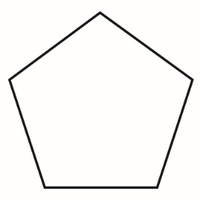

Exploring Angles in Polygons (cont’d)
Measurement
Unit 1 Line Master 7b

Part B:
- Decompose each of the shapes into triangles.
- The vertices of the triangles should coincide with the vertices
of the polygon (i.e., no vertex of a triangle should be inside
the polygon).
- How might you use what you know about the interior angles
of a triangle to determine the sum of the interior angles of
these polygons?
If n represents the number of sides, write a formula you could use
to determine the sum of the interior angles of any polygon.

