Angle Relationships 2
Measurement
Unit 1 Line Master 6a

Part A:
Look at the angle measurements in the diagrams.
What relationships do you notice?
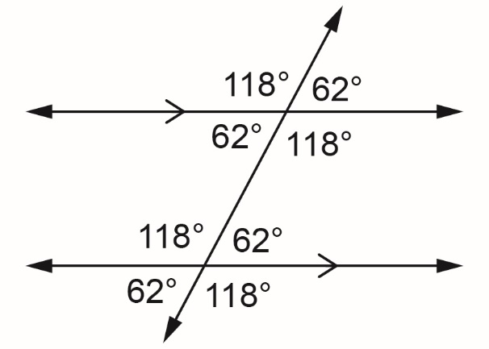  a) | 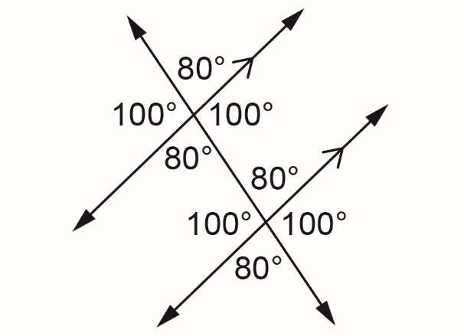  b)

c) Predict which angle measurements will be equal to one another
in the diagram. Measure with your protractor to check.
Label the diagram with the actual angle measurements.
Were your predictions correct?
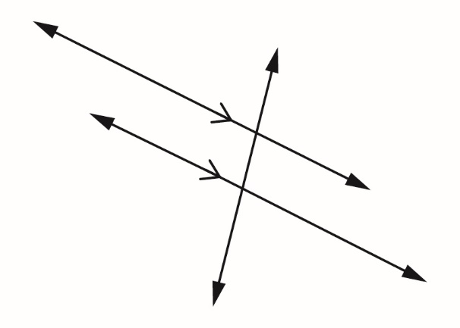

Angle Relationships 2 (cont’d)
Measurement
Unit 1 Line Master 6b

Part B:
The two triangles are similar. How do you know?
Measure the interior angles of each of these triangles.
What do you notice?

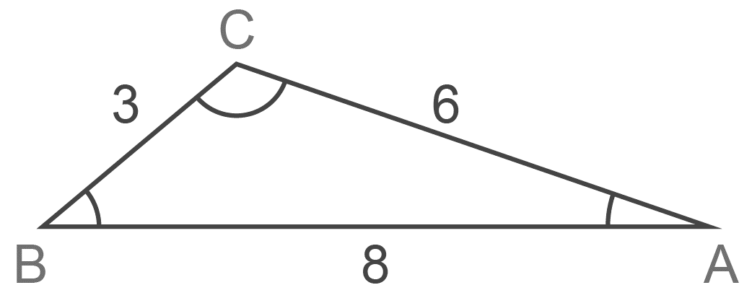

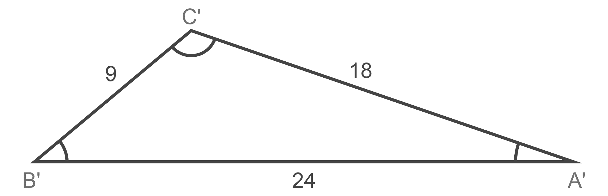
122⁰
39⁰
19⁰

