Angle Relationships
Measurement
Unit 1 Line Master 5a

Part A:
Draw a transversal through each pair of parallel lines, as shown
in the examples. Use a protractor to measure all of the angles formed. Label each diagram with the angle measurements.
Look for and make a note of any new relationships you notice between the angle measurements.
Examples of transversals:
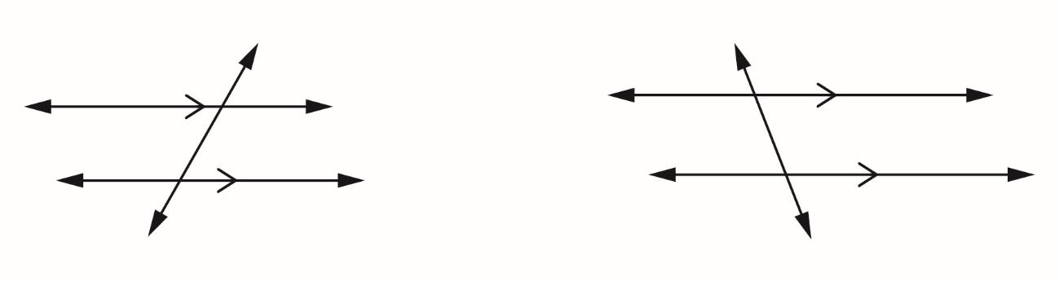
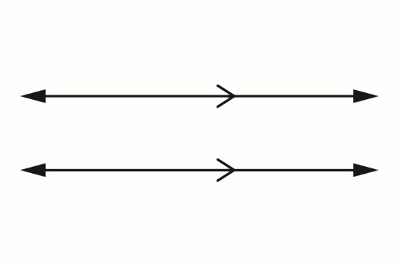  a) | 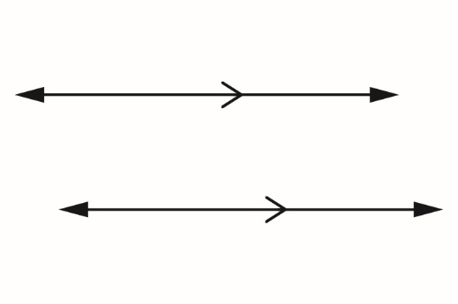  b)
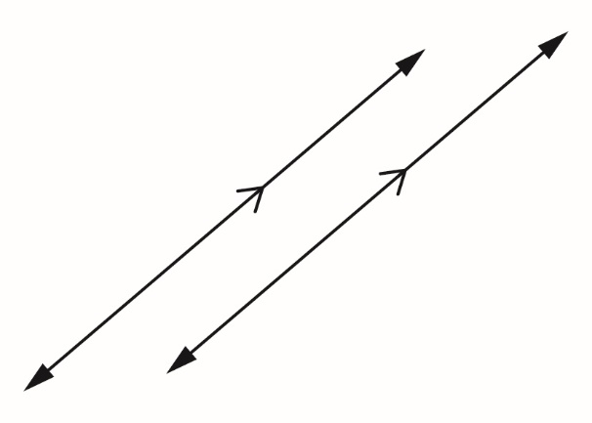
c)

Angle Relationships (cont’d)
Measurement
Unit 1 Line Master 5b

Part B:
The two triangles are similar. How do you know?
Measure the interior angles of each of these triangles.
What do you notice?
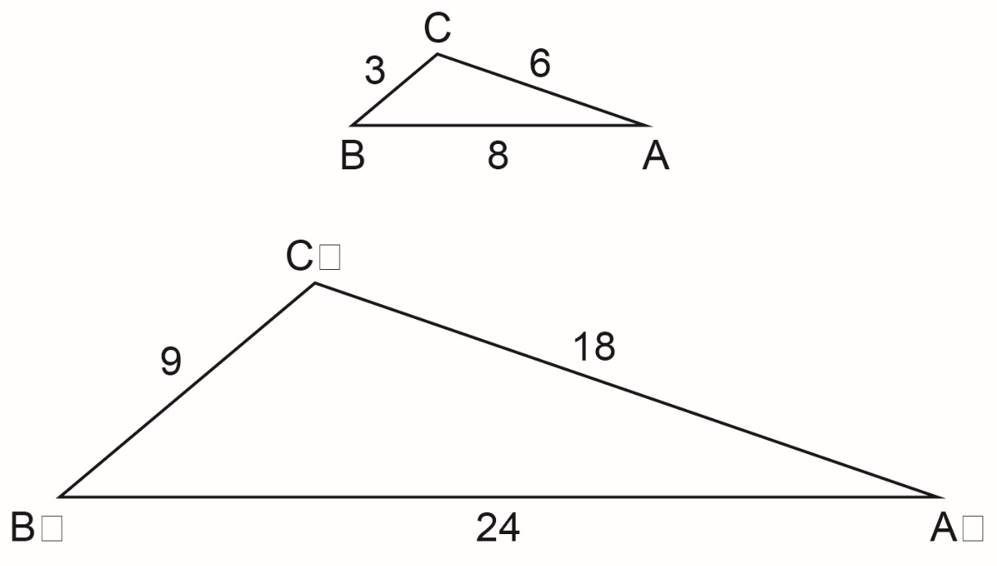
C’
B’
A’

