Playground Blueprint

**Geometry**

**Unit 1 Line Master 3a**

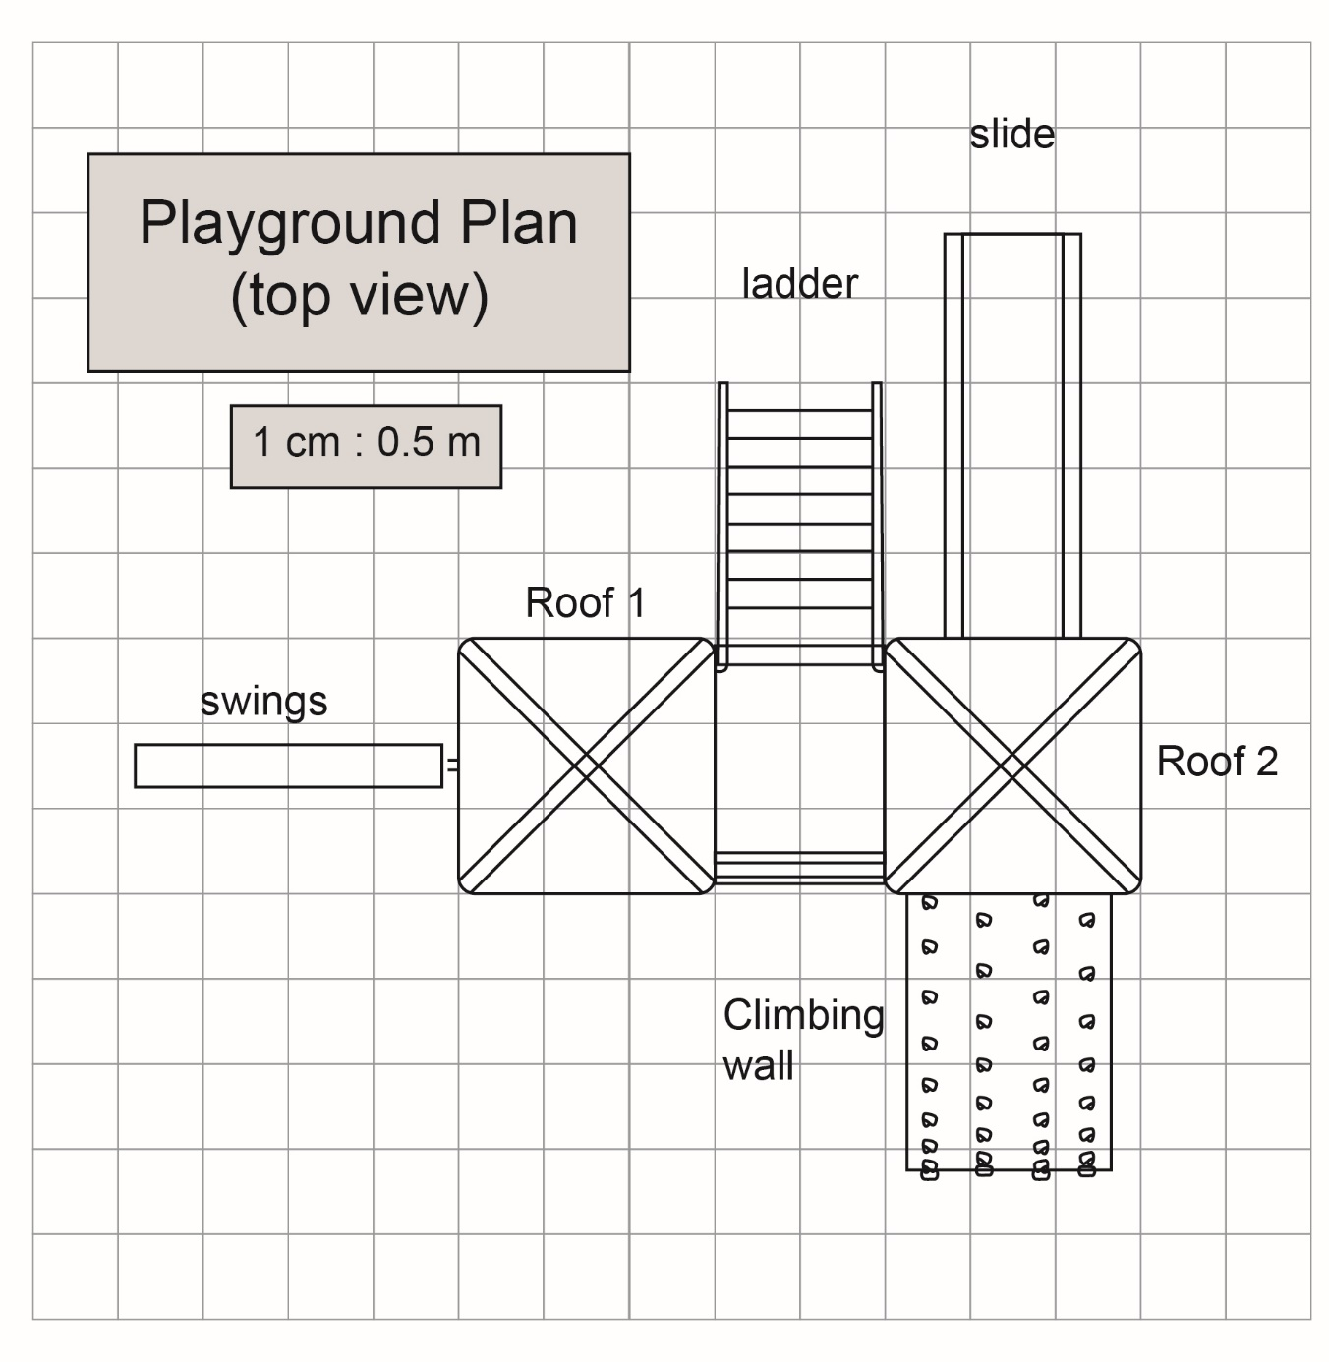

Playground Blueprint (cont’d)

**Geometry**

**Unit 1 Line Master 3b**

|  |  |  |  |  |  |  |  |  |  |  |  |  |  |  |  |  |  |  |  |  |  |  |  |  |  |  |  |  |  |  |  |  |  |
| --- | --- | --- | --- | --- | --- | --- | --- | --- | --- | --- | --- | --- | --- | --- | --- | --- | --- | --- | --- | --- | --- | --- | --- | --- | --- | --- | --- | --- | --- | --- | --- | --- | --- |
|  |  |  |  |  |  |  |  |  |  |  |  |  |  |  |  |  |  |  |  |  |  |  |  |  |  |  |  |  |  |  |  |  |  |
|  |  |  |  |  |  |  |  |  |  |  |  |  |  |  |  |  |  |  |  |  |  |  |  |  |  |  |  |  |  |  |  |  |  |
|  |  |  |  |  |  |  |  |  |  |  |  |  |  |  |  |  |  |  |  |  |  |  |  |  |  |  |  |  |  |  |  |  |  |
|  |  |  |  |  |  |  |  |  |  |  |  |  |  |  |  |  |  |  |  |  |  |  |  |  |  |  |  |  |  |  |  |  |  |
|  |  |  |  |  |  |  |  |  |  |  |  |  |  |  |  |  |  |  |  |  |  |  |  |  |  |  |  |  |  |  |  |  |  |
|  |  |  |  |  |  |  |  |  |  |  |  |  |  |  |  |  |  |  |  |  |  |  |  |  |  |  |  |  |  |  |  |  |  |
|  |  |  |  |  |  |  |  |  |  |  |  |  |  |  |  |  |  |  |  |  |  |  |  |  |  |  |  |  |  |  |  |  |  |
|  |  |  |  |  |  |  |  |  |  |  |  |  |  |  |  |  |  |  |  |  |  |  |  |  |  |  |  |  |  |  |  |  |  |
|  |  |  |  |  |  |  |  |  |  |  |  |  |  |  |  |  |  |  |  |  |  |  |  |  |  |  |  |  |  |  |  |  |  |
|  |  |  |  |  |  |  |  |  |  |  |  |  |  |  |  |  |  |  |  |  |  |  |  |  |  |  |  |  |  |  |  |  |  |
|  |  |  |  |  |  |  |  |  |  |  |  |  |  |  |  |  |  |  |  |  |  |  |  |  |  |  |  |  |  |  |  |  |  |
|  |  |  |  |  |  |  |  |  |  |  |  |  |  |  |  |  |  |  |  |  |  |  |  |  |  |  |  |  |  |  |  |  |  |
|  |  |  |  |  |  |  |  |  |  |  |  |  |  |  |  |  |  |  |  |  |  |  |  |  |  |  |  |  |  |  |  |  |  |
|  |  |  |  |  |  |  |  |  |  |  |  |  |  |  |  |  |  |  |  |  |  |  |  |  |  |  |  |  |  |  |  |  |  |
|  |  |  |  |  |  |  |  |  |  |  |  |  |  |  |  |  |  |  |  |  |  |  |  |  |  |  |  |  |  |  |  |  |  |
|  |  |  |  |  |  |  |  |  |  |  |  |  |  |  |  |  |  |  |  |  |  |  |  |  |  |  |  |  |  |  |  |  |  |
|  |  |  |  |  |  |  |  |  |  |  |  |  |  |  |  |  |  |  |  |  |  |  |  |  |  |  |  |  |  |  |  |  |  |
|  |  |  |  |  |  |  |  |  |  |  |  |  |  |  |  |  |  |  |  |  |  |  |  |  |  |  |  |  |  |  |  |  |  |
|  |  |  |  |  |  |  |  |  |  |  |  |  |  |  |  |  |  |  |  |  |  |  |  |  |  |  |  |  |  |  |  |  |  |
|  |  |  |  |  |  |  |  |  |  |  |  |  |  |  |  |  |  |  |  |  |  |  |  |  |  |  |  |  |  |  |  |  |  |
|  |  |  |  |  |  |  |  |  |  |  |  |  |  |  |  |  |  |  |  |  |  |  |  |  |  |  |  |  |  |  |  |  |  |
|  |  |  |  |  |  |  |  |  |  |  |  |  |  |  |  |  |  |  |  |  |  |  |  |  |  |  |  |  |  |  |  |  |  |
|  |  |  |  |  |  |  |  |  |  |  |  |  |  |  |  |  |  |  |  |  |  |  |  |  |  |  |  |  |  |  |  |  |  |
|  |  |  |  |  |  |  |  |  |  |  |  |  |  |  |  |  |  |  |  |  |  |  |  |  |  |  |  |  |  |  |  |  |  |
|  |  |  |  |  |  |  |  |  |  |  |  |  |  |  |  |  |  |  |  |  |  |  |  |  |  |  |  |  |  |  |  |  |  |
|  |  |  |  |  |  |  |  |  |  |  |  |  |  |  |  |  |  |  |  |  |  |  |  |  |  |  |  |  |  |  |  |  |  |
|  |  |  |  |  |  |  |  |  |  |  |  |  |  |  |  |  |  |  |  |  |  |  |  |  |  |  |  |  |  |  |  |  |  |
|  |  |  |  |  |  |  |  |  |  |  |  |  |  |  |  |  |  |  |  |  |  |  |  |  |  |  |  |  |  |  |  |  |  |
|  |  |  |  |  |  |  |  |  |  |  |  |  |  |  |  |  |  |  |  |  |  |  |  |  |  |  |  |  |  |  |  |  |  |
|  |  |  |  |  |  |  |  |  |  |  |  |  |  |  |  |  |  |  |  |  |  |  |  |  |  |  |  |  |  |  |  |  |  |
|  |  |  |  |  |  |  |  |  |  |  |  |  |  |  |  |  |  |  |  |  |  |  |  |  |  |  |  |  |  |  |  |  |  |
|  |  |  |  |  |  |  |  |  |  |  |  |  |  |  |  |  |  |  |  |  |  |  |  |  |  |  |  |  |  |  |  |  |  |
|  |  |  |  |  |  |  |  |  |  |  |  |  |  |  |  |  |  |  |  |  |  |  |  |  |  |  |  |  |  |  |  |  |  |
|  |  |  |  |  |  |  |  |  |  |  |  |  |  |  |  |  |  |  |  |  |  |  |  |  |  |  |  |  |  |  |  |  |  |
|  |  |  |  |  |  |  |  |  |  |  |  |  |  |  |  |  |  |  |  |  |  |  |  |  |  |  |  |  |  |  |  |  |  |
|  |  |  |  |  |  |  |  |  |  |  |  |  |  |  |  |  |  |  |  |  |  |  |  |  |  |  |  |  |  |  |  |  |  |
|  |  |  |  |  |  |  |  |  |  |  |  |  |  |  |  |  |  |  |  |  |  |  |  |  |  |  |  |  |  |  |  |  |  |
|  |  |  |  |  |  |  |  |  |  |  |  |  |  |  |  |  |  |  |  |  |  |  |  |  |  |  |  |  |  |  |  |  |  |