Creating Tessellations
Geometry
Unit 1 Line Master 12a

Part A: One-Cut Tessellation

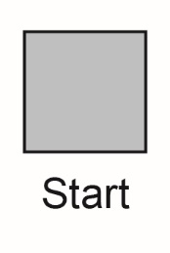
1. Cut out a 10-cm × 10-cm square from Master 13.

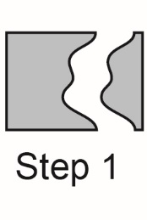
2. Starting and ending on the same side, draw and cut out a simple shape.

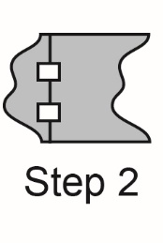
3. Translate the cut-out shape across the shape to the opposite side. Tape it to this side.

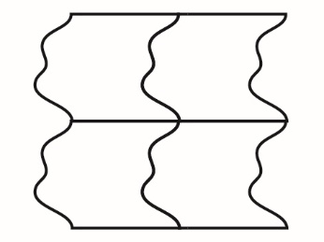
4. You now have a tessellating tile. Trace it onto your paper repeatedly to create your tessellation.

Creating Tessellations (cont’d)
Geometry
Unit 1 Line Master 12b

Part B: Two-Cut Tessellation

1. Follow steps 1–3 from above.

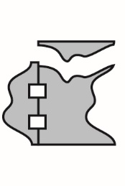
2. Choose an untouched side of the
square and cut-out another shape
from this side.

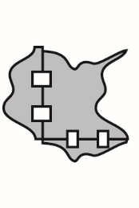
3. Translate the cut out shape across the shape to the opposite side. Tape it to this side.

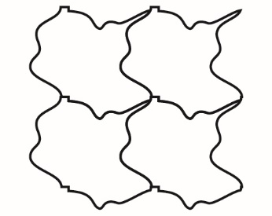
4. You now have a tessellating tile. Trace it onto your paper repeatedly to create your tessellation.

Creating Tessellations (cont’d)
Geometry
Unit 1 Line Master 12c

Part C: Rotations in Tessellations

1. Cut out a 10-cm × 10-cm square.

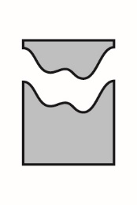
2. Cut a simple shape out of the top side
of the square. Cut from one vertex to
the other vertex.

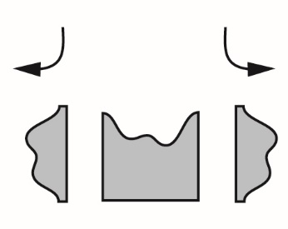
3. Explore what happens when you rotate
this piece and attach it to another side. Can you find a way to rotate it so that
the new shape tessellates?

Creating Tessellations (cont’d)
Geometry
Unit 1 Line Master 12d

4. Once you have created a one-cut shape that tessellates,
explore cutting a second shape out of another side and
rotating it. Can you find a way to do this so that the new
shape tessellates?

5. Describe any rotations you found that work.

