Would You Rather?
Answers

Financial Literacy
Unit 1 Line Master 6a

Scenario A
For $5000 in a savings account for 4 years, would you rather have:
• an annual rate of 4% simple interest, or
• an annual rate of 3% compound interest?
Simple interest: $800;
Compound interest $627.54
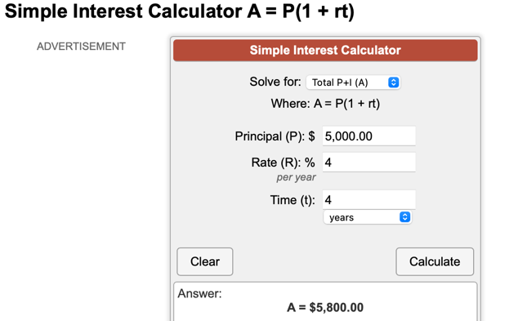
https://www.calculatorsoup.com/calculators/financial/simple-interest-plus-principal-calculator.php

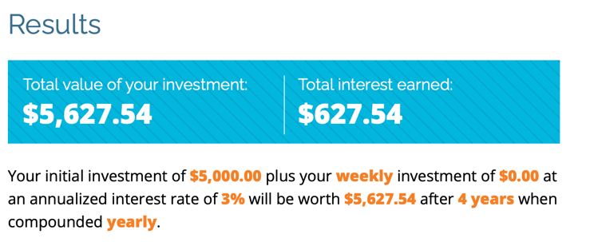
https://www.getsmarteraboutmoney.ca/calculators/compound-interest-calculator/

Would You Rather?
Answers (cont’d)

Number
Unit 4 Line Master 6b

Scenario B
For a loan of $5000 for 5 years, then you repay the loan,
would you rather have:
• an annual rate of 3.25% simple interest, or
• an annual rate of 2.75% compound interest?

Simple interest: $812.50
Compound interest: $726.37
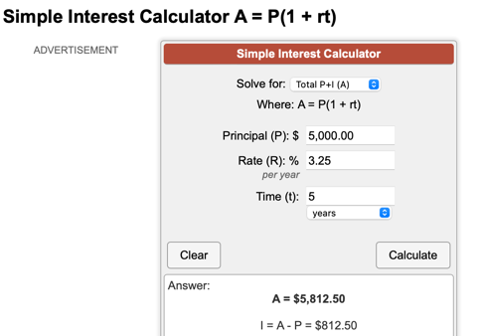
https://www.calculatorsoup.com/calculators/financial/simple-interest-plus-principal-calculator.php

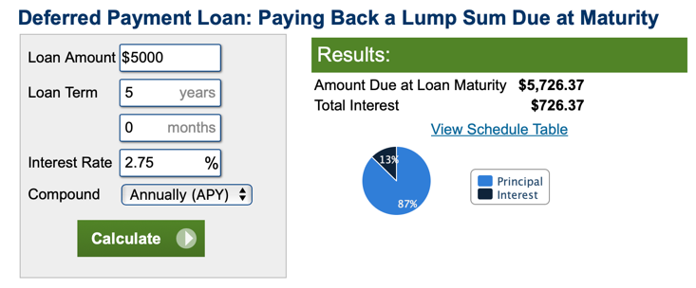
https://www.calculator.net/loan-calculator.html?c2loanamount=5000&c2loanterm=5&c2loantermmonth=0&c2interestrate=2.75&c2compound=annually&x=60&y=24&type=2#intheend

Would You Rather?
Answers (cont’d)

Number
Unit 4 Line Master 6c

Scenario C
For a credit card debt of $5000 with an annual interest rate
of 17.5% compounded monthly, would you rather pay:
• the minimum monthly amount only, or
• the minimum amount plus $10, or
• a fixed monthly rate of $200?

Paying a fixed amount each month saves $3276.28
https://itools-ioutils.fcac-acfc.gc.ca/CCPC-CPCC/CCPCCalc-CPCCCalc-eng.aspx
