Exploring Probability Using Venn Diagrams
Understands that the sum of all possible probabilities is 100%  When tossing 2 coins, the possible outcomes are:  H, H; T, T; T, H; H, T  The probability of 2 heads is 25%.  The probability of 2 tails is 25%.  The probability of 1 heads and 1 tails is 50%.  The sum of the probabilities is:  25% + 25% + 50% = 100% | Explains a Venn diagram with probabilities  Students in a Grade 8 class were asked whether they skate or ski.  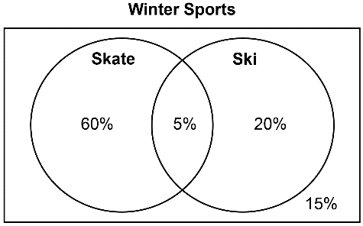  65% of students skate.  25% of students ski.  5% of students skate and ski.  15% of students neither skate  nor ski. | Calculates percents in a Venn diagram  There are 25 students in the class.  About how many students neither skate nor ski?  15% of 25  = 0.15 × 25 = 3.75  About 4 students neither skate  nor ski. | Uses and explains how a Venn diagram represents probabilities  I asked students in my class whether they played baseball or soccer in the summer.  Here are the results.  30% play soccer.  80% play baseball.  20% play baseball and soccer.  10% play neither sport.  The percents on the Venn diagram add to 100%, but the sum of the separate percents above is greater than 100% because the 20%  who play both sports is added  two more times.  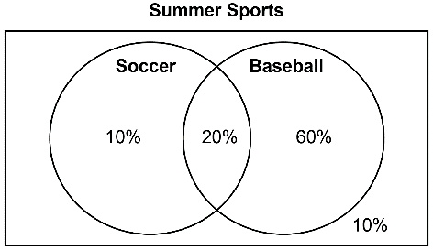
Observations/Documentation

