Creating an Infographic
Identifies key features, message, and audience for an infographic  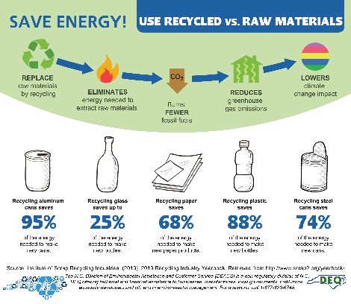  Source: deq.nc.gov  “I found this infographic online.  It encourages people to recycle by showing how recycling saves energy. It uses lots of colourful pictures, short pieces of text, and percents. I think the audience is kids and adults.” | Rates the effectiveness of an infographic and suggests improvements  “I think it does a really good job.  It’s easy to read. I knew recycling reduced the amount of stuff going to landfill, but I never really thought about how it could save energy.  The only thing I might add is some information about how people can recycle in their community.” | Collects and uses data to decide on a message to convey with an infographic  “My mom sometimes complains about our electricity bills. I would research online to learn about ways to reduce energy use around the house. My infographic would encourage people to save energy.” | Creates an infographic to tell a story about data to a particular audience  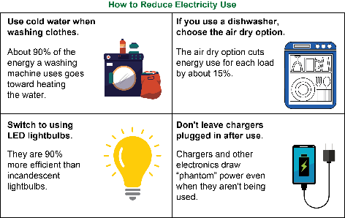  Source: Created using data from Ontario Ministry of Energy
Observations/Documentation

