Using Data to Make Convincing Arguments
Recognizes that data can be selected or presented to promote a viewpoint  “If an advertiser wants you to buy  a particular product, they will emphasize good aspects of the product and not mention any negatives. Sometimes I look for  non-biased reviews before making  a purchase.” | Identifies misleading graphs and bias in data  “This graph is misleading because the vertical scale doesn’t start at 0. So, the bars for the United States and Mexico look much taller compared to the bar for Canada than is justified by the numbers for each country.”  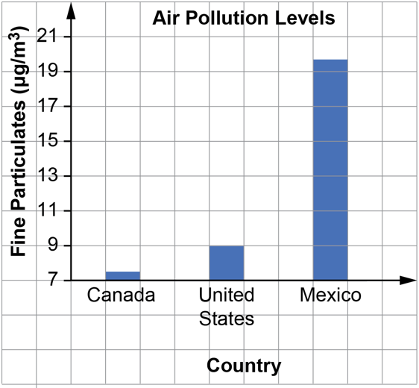  Source: iqair.com/ca | Creates or selects graphs to emphasize a stated viewpoint  “If I want to graph these data and mislead the viewer into thinking Christine Sinclair scored way more goals than the other high scorers,  I would start the scale on the vertical axis at 110 or 120 so some players have really short bars.  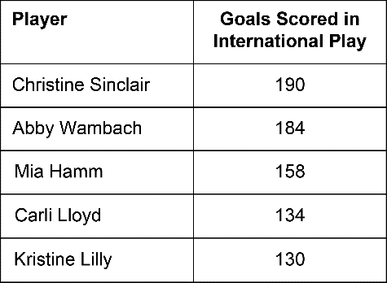  Source: olympics.com | Conducts research and graphs data to promote a stated viewpoint  “I want to convince my family to let me play soccer. So, I did some research on typical costs to participate in different activities.  I choose the activities and graphed the data to make sure soccer looks much cheaper than the others.”  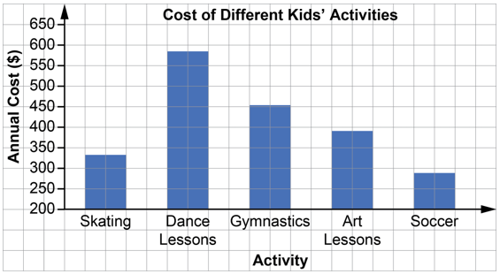  Source: Data from Ipsos poll as reported by Global News Canada
Observations/Documentation

