Investigating Relationships in Data
Chooses variables and collects data about them  “Hockey is my favourite sport.  I wonder if there might be relationships between salaries, players ages, and how many points a team has at the end of season.” | Predicts possible relationships and graphs bivariate data for analysis  “I graphed the total salaries paid and the points earned for the 2022/23 season. I know there is a salary cap and I think that’s because if a team pays players more they will get better players, win more, and earn more points.”  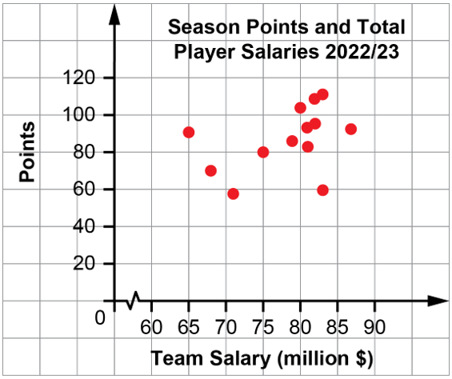  Source: spotrac.com | Identifies and describes relationships between variables  Source: spotrac.com  “In my scatter plot I don’t see the strong relationship I expected to. Some teams who spend less on salaries win lots of games and some who pay more don’t win so many.” | Describes limitations of their analysis and further possible research  “I didn’t graph data for all the teams because there were a lot, so I think  I should add more to the graph to see if it makes a difference. I also wonder if it might make a difference looking at data from a different season.”
Observations/Documentation

