Using Different Types of Graphs
Identifies and interprets different types of graphs  “My soccer coach made this pictograph. I can see that my team, Team E, sold the most cookies in the fundraiser.”  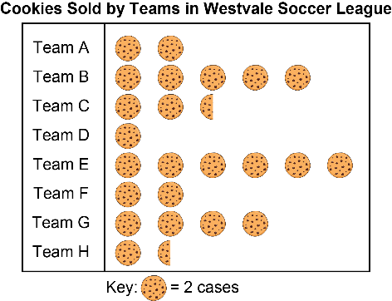  Source: Data collected by students | Recommends graph types based on the data to be shown and justifies choices  One evening, a student measured and recorded the temperature every hour. What type of graph should they draw to display it?  “I think they should draw a line graph. They have quantitative, continuous data that changes over time. They could use the graph to make predictions.” | Draws appropriate graph to represent data  “I drew a line graph with the time on the horizontal axis and the temperature on the vertical axis. The graph shows that the temperature is steadily decreasing.”  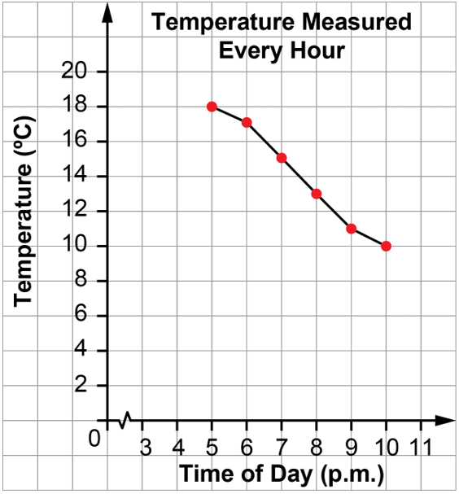  Source: Data collected by students | Poses and answers questions about graphed data  Source: Data collected by students  “I wonder what the temperature would have been at 4:00 p.m. and at 11:00 p.m.?  Since the temperature is decreasing by 1°C or 2°C every hour, I think at 4:00 p.m. it might have been about 19°C and at 11:00 p.m., it might have been about 9°C.”

Observations/Documentation

