Exploring Scatter Plots
Recognizes when to use a scatterplot to represent data  “If I have two quantitative variables and I want to see if there is a relationship between them, I use a scatter plot. This makes it easier to see any patterns that may exist in the data.“ | Draws a scatter plot, correctly identifying which variable to plot on the horizontal axis  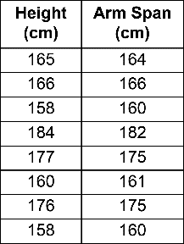  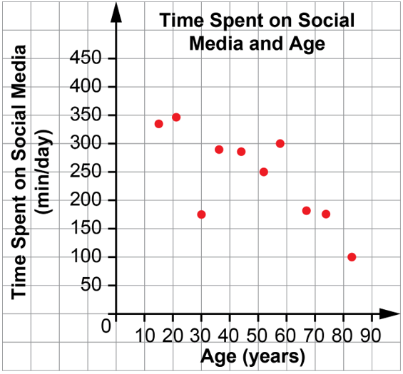  Source: Student collected data | Interprets scatter plots, including recognizing limitations  “In my scatter plot of arm span and height, I can see that as you move right along the x-axis, the points move up. This is a positive relationship and means that as a person’s height increases, so does their arm span.  It would be good to collect and add more data since 8 points isn’t very many.” | Poses question about possible relationships between two variables and predicts answer  “I know that when I don’t sleep enough, I’m tired the next day. I wonder if there is a relationship between how a person rates their energy level on a scale of 1 to 10 and the number of hours of sleep they got the night before. I think there will be a positive relationship, the more sleep they got, the higher they will rate their energy level.”
Observations/Documentation

