Exploring Types of Data
Collects and organizes one-variable data in a table of values  “We asked each of our classmates what their eye colour is. We recorded the results in a table using a tally mark for each student.  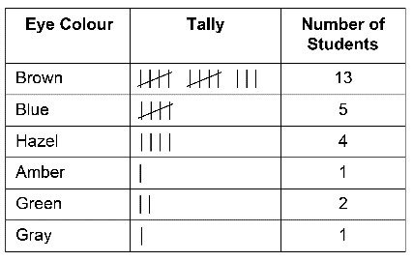  Source: Data collected by students | Collects and organizes two-variable data in a table of values  “We want to see if taller people have bigger shoe sizes. We will measure the height of each of our classmates and ask them their shoe size. Once we have data for each student, we’ll organize them in a table according to height and check if as the height increases the shoe size does  as well.”  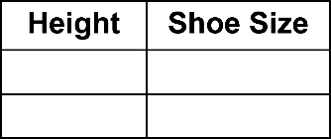 | Recognizes the differences between types of data  “Both shoe size and height are quantitative data. Height is continuous because a person’s height can be any decimal or fractional measurement, but shoe size is discrete.” | Writes and answers questions about one- or two-variable data  “Zoe collected data about the favourite video games of students in Grade 8. My question is which game is most popular. I also wonder if the responses would be different for younger students. Zoe or I would need to collect more data to answer the second question.”
Observations/Documentation

