Oil Transportation Data
Data
Unit 1 Line Master 9

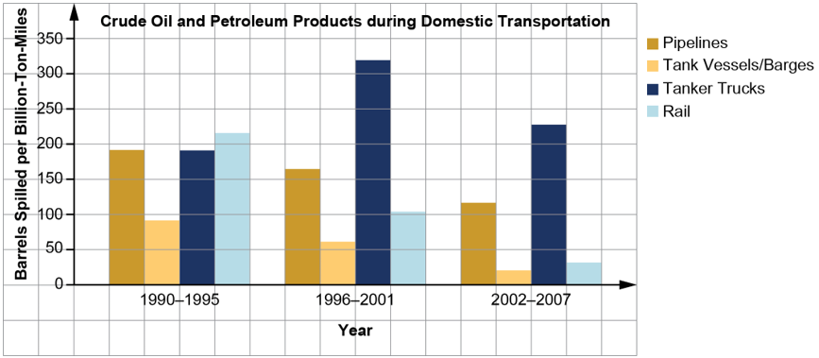
Source: Prepared by CRS; oil spill colume data from Dagmar Etkin, Analysis of U.S. Oil Spillage, API Publication 356, August 2009; ton-mile data from Association of Oil Pipelines, Report on Shifts in Petroleum Transportation: 1990–2009, February 2012.
Notes: Pipelines include onshore and offshore pipelines. The time periods were chosen based on the available annual data for both spill volume and ton-miles. The values for each time period are averages of annual data for each six-year period.

Additional data I researched:

