Using Code to Simulate Tossing Two Coins
Interprets provided code that uses random numbers to simulate tossing two fair coins  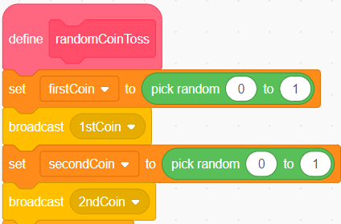  This part of the code simulates tossing two coins one time. The code uses 0 to represent a head and 1 as a tail. It can be used in a repeat to simulate many tosses. | Changes code so that the experimental probabilities are closer to the theoretical probabilities  By changing the number of repeats to a very large number, I can get experimental probabilities that are very close to the theoretical probabilities. | Finds and fixes errors in code  and/or pseudocode that simulates coin tosses  When I ran my code, the probability for 2 tails was much greater than for 2 heads. I looked at my code and noticed I used the wrong random number range for the coins. | Alters code or pseudocode  to simulate tossing 1 fair and  1 unfair coin  I changed the random number range for one of my coins to 0 to 3, with 1, 2, and 3 all representing tails.  This represents a coin with a $\frac{3}{4}$ probability of landing tails.
Observations/Documentation

