Writing Code to Create a Personal Data Analysis Program
Reads and interprets pseudocode and/or code to predict what will happen when a program is run  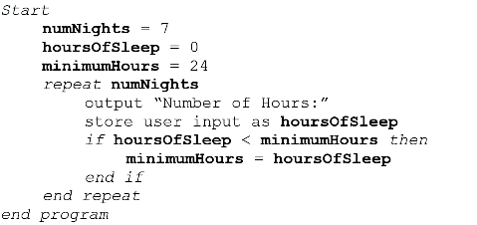  This program asks the user to input the number of hours they sleep each night for 1 week, then determines the minimum number. | Adds blocks to code to further analyze a user’s data  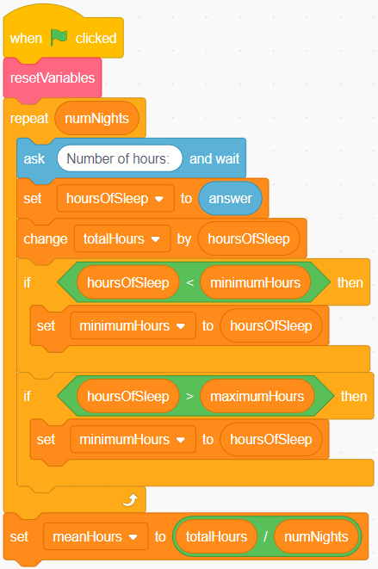  I added blocks to determine the maximum, total, and mean number of hours the user sleeps each night. | Finds and fixes errors in code and/or pseudocode  My program wasn’t displaying the mean properly. The number was way too big. I looked at my code and saw that I had multiplied the total by the number of days instead of dividing. | Alters code or writes new code to analyze the amount of time a user spends on screens  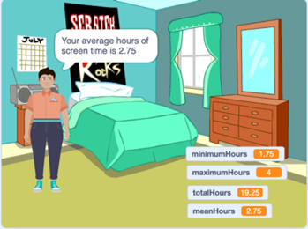  I started with the Hours of Sleep program that included determining maximum, total, and mean values. All I had to do was change some of the variable names.

Observations/Documentation

