Writing Code to Calculate Volume and Surface Area
Reads and interprets pseudocode relating to volume and surface area of a cylinder  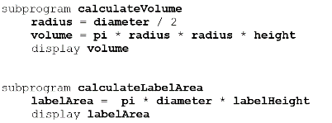  The first subprogram calculates the volume of a cylinder, the second calculates the area of a label that is wrapped around the curved part of the cylinder. | Predicts what will happen when a user enters data in a program  A client uses Yindi’s Design Quote program and enters 8.4 cm as the diameter and 3.8 cm as the height and label height. A design cost of 150.3432 will be shown. | Alters or completes given pseudocode and/or code to change values or add missing calculations  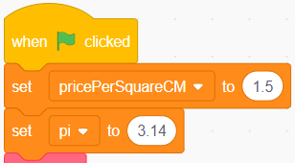  If Yindi wants to change the price they charge to design the labels, they can enter a new number for the pricePerSquareCM. | Alters code or writes new code to determine volume and surface area of a rectangular prism  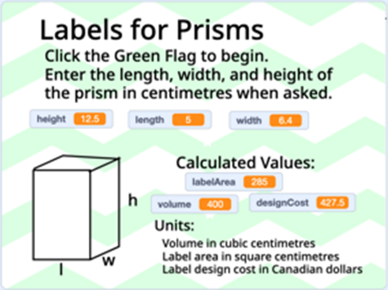  I changed Yindi’s code to ask for a length, width, and height in centimetres. My code uses this information to calculate and display the volume of the prism in cubic centimetres and surface area of four faces (not top or bottom).
Observations/Documentation

