Altering Code for Translations and Predicting the Output
Reads and interprets pseudocode relating to translations  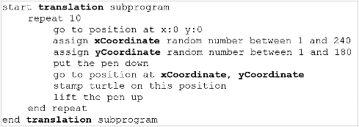  This subprogram has the turtle start at (0, 0), move to a random point, and stamp a turtle. | Recognizes the relationship between pseudocode and code  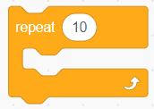  When pseudocode calls for an action to be repeated, the coder uses a repeat block in their code. | Recognizes the effects of  altering code  What will happen if the number of repetitions in the code is changed from 10 to 100?  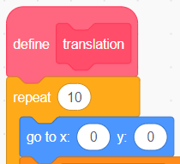  100 turtles will be stamped  instead of 10. | Alters code so the turtles are stamped in a specified quadrant  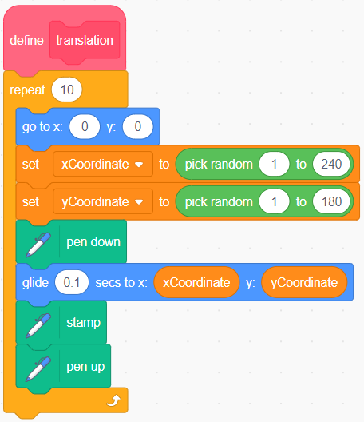  If I alter this code so that the  x-coordinate is a random number between –240 and –1, the turtles  will be stamped in Quadrant 2 instead of Quadrant 1.
Observations/Documentation

