Coin Toss Simulator Challenges

Algebra
Unit 3 Line Master 9a

You will be altering code in the Coin Toss Simulator application
from Master 8a–f.
Remember: you must be logged in to save your work in your
Scratch account.
https://scratch.mit.edu/projects/719300889/editor/
Note:
For Challenge 4, you will need access to a spreadsheet program.

Challenge 1: Obtaining Input from the User
Alter the code so the user can enter the number of trials
they want when prompted.
Hint:
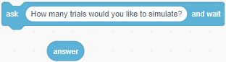

Challenge 2: Simulating an Unfair Coin

In the simulator for Master 8a–f, you worked with two fair coins.
This means that each coin is equally likley to land heads as tails.
How could you alter the code so that one of the coins is unfair?
That is, one coin is slightly weighted, which means it is more likely to land one way than the other.

Coin Toss Simulator Challenges
(cont’d)

Algebra
Unit 3 Line Master 9b

- Alter the code so the firstCoin has a $\frac{1}{3}$ probability of landing
heads and $\frac{2}{3}$ probability of landing tails.
Test the program with a large number of trials.
How does the change affect the experimental probabilities?
Use a tree diagram to explain.
Hint:
- Change the pick random range for the firstCoin variable
to include three possibilities (0 to 2).
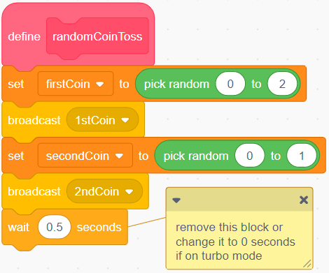
- Alter the code so the first coin has $\frac{1}{4}$ probability of landing
heads and $\frac{3}{4}$ probability of landing tails.
Test the program with a large number of trials.
How does the change affect the experimental probabilities?
Is it what you expected? Explain.
Coin Toss Simulator Challenges
(cont’d)

Algebra
Unit 3 Line Master 9c

Challenge 3: Considering HT and TH as Separate Outcomes
Suppose you toss two different coins, such as a nickel and a dime.
In this case, HT and TH are not the same result.
Alter the code so HT and TH are separate outcomes.
What are the theoretical probabilities with HT and TH as
separate outcomes?
Check to see if your experimental probabilities match what
is expected.
Hint:
You will need to make additional variables, keep track of the
number of times they occur, and calculate their probabilities.
Challenge 4: Exporting and Graphing the Experimental Outcomes
If you have access to a spreadsheet program such as Google Sheets or Microsoft Excel, you can export data from the list that
is created by the simulator in Master 8a–f and generate bar graphs
to show the results.
1. Run the coin toss simulator from Master 8a–f with 1000 trials.

Coin Toss Simulator Challenges
(cont’d)

Algebra
Unit 3 Line Master 9d

2. Right click on the TossCombo List on the Stage
and select export.
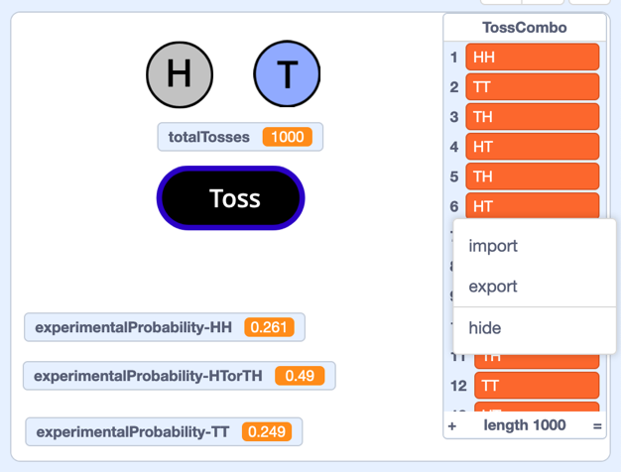
3. Save the TossCombo text file in a folder to use later.
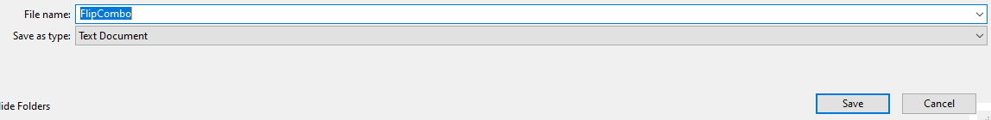
4. Now you can import the data into the spreadsheet program you
use and use the spreadsheet’s charting functions to graph them.
5. If you completed Challenge 3, you can follow a similar process
to export and graph the results of a simulation involving
an unfair coin.
Predict what the graph will look like when your first coin has $\frac{1}{3}$
probability of landing heads and $\frac{2}{3}$ probability of landing tails.

