Answers

Algebra
Unit 3 Line Master 9e

Challenge 1: Obtaining Input from the User
As described in the hint, add a block that asks the user how
many trials they would like to simulate. Use the answer to set
the number of repeats.
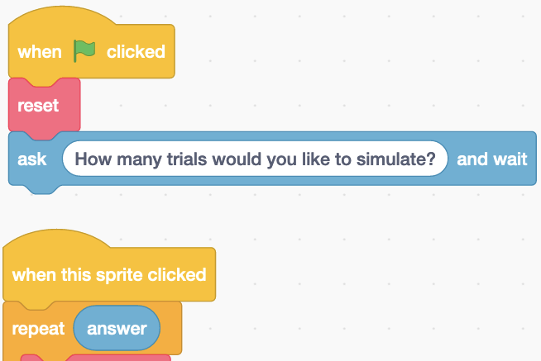

Challenge 2: Simulating an Unfair Coin
Alter the code as described in the hint.
For a large number of trials, the experimental probabilities

should approach HH: $\frac{1}{6}$, TT: $\frac{2}{6}$ or $\frac{1}{3}$, HT or TH: $\frac{1}{6}$ + $\frac{2}{6}$ = $\frac{3}{6}$ or $\frac{1}{2}$

Answers (cont’d)

Algebra
Unit 3 Line Master 9f

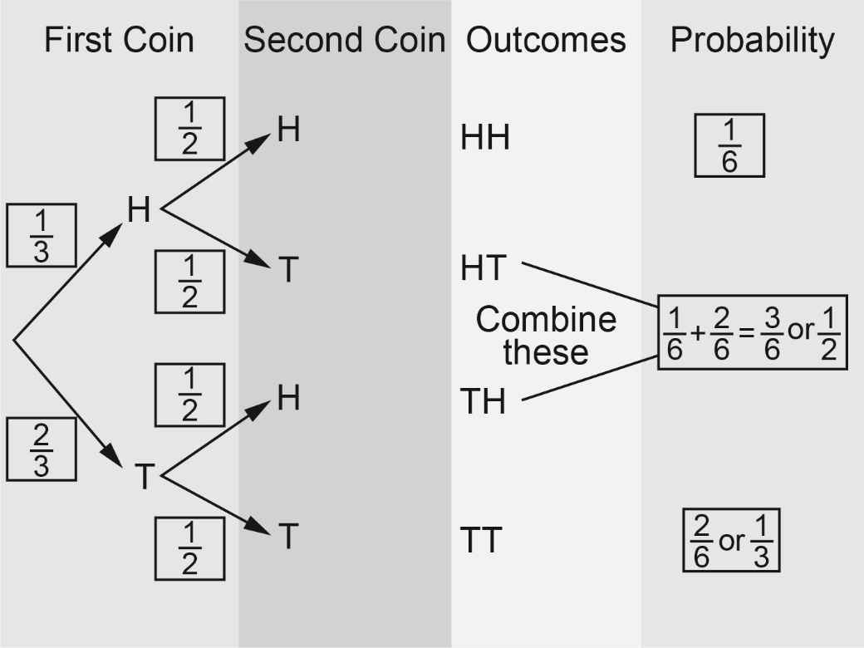

To simulate an unfair coin that has a $\frac{1}{4}$ probability of landing

heads, change the pick random range for the firstCoin variable to include four possibilities (0 to 3).
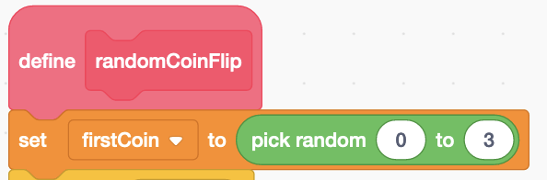
For a large number of trials, the experimental probabilities

should approach HH: $\frac{1}{8}$, TT: $\frac{3}{8}$, HT or TH: $\frac{1}{8}$ + $\frac{3}{8}$ = $\frac{4}{8}$, or $\frac{1}{2}$

Answers (cont’d)

Algebra
Unit 3 Line Master 9g

Challenge 3: Considering HT and TH as Separate Outcomes
New variables should be created for HT, TH, experimentalProbability-HT, and experimentalProbability-TH. Four of the subprograms need to be altered as shown below to reflect the fact that HT and TH are no longer treated as the
same outcome.

The reset subprogram: The subprogram calculating the
probabilities:

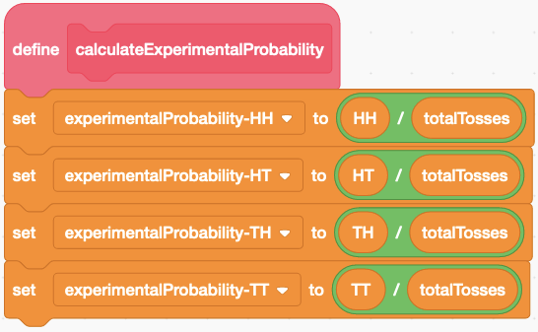
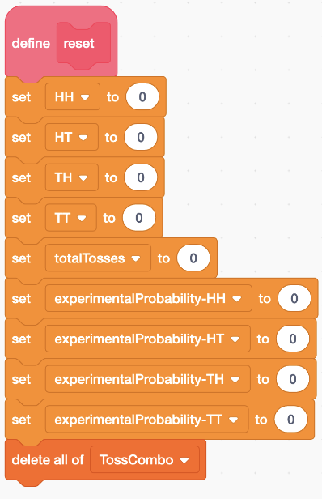

Answers (cont’d)

Algebra
Unit 3 Line Master 9h

The subprograms called firstTossHeads and firstTossTails:

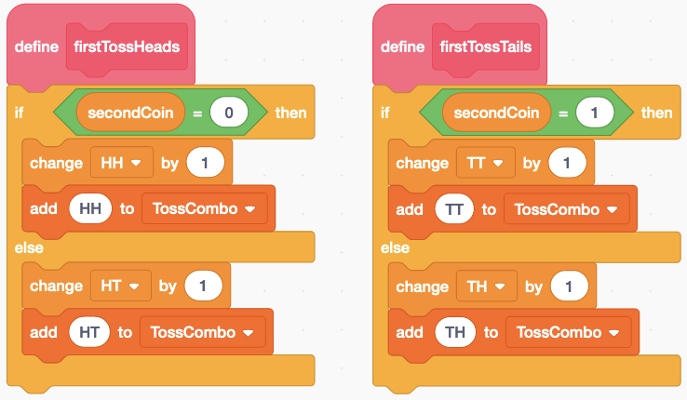

The theoretical probabilities are HH: $\frac{1}{4}$, HT: $\frac{1}{4}$, TH: $\frac{1}{4}$, TT: $\frac{1}{4}$;
for a large number of trials, the experimental probabilities should approach these numbers. Here is a sample result for 1000 trials:
