Writing and Altering Code
for a Coin Toss Simulator

Algebra
Unit 3 Line Master 8a

Here’s the starting Scratch code:
https://scratch.mit.edu/projects/719187744/editor/

If you have a Scratch login, save the project in your
Scratch account by selecting Remix at the top of the screen.
A login is not required to work with the code, but you will not
be able to save your changes without it.
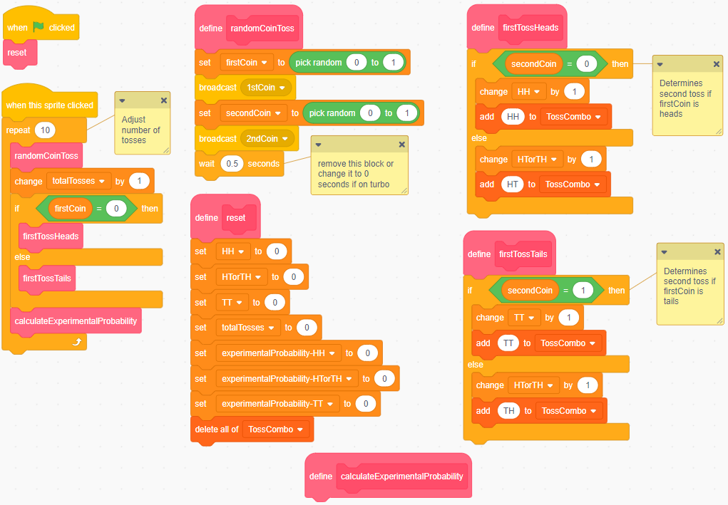
The code simulates repeatedly tossing two coins.

Writing and Altering Code
for a Coin Toss Simulator (cont’d)

Algebra
Unit 3 Line Master 8b

Click on the green flag to reset the application.
Click on the Toss button 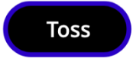 to execute the code.
The starting code tosses two coins 10 times.
1. Where in the code is the number of tosses specified?
2. Which random number is used to represent heads?
To represent tails?
3. Alter the code to toss the two coins 100 times.
Notice the coins toss every 0.5 s, which is specified in the
randomCoinToss subprogram.
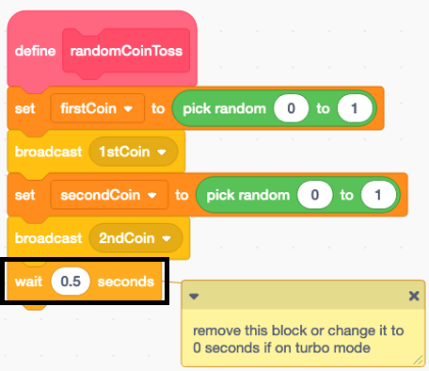
Toss the coins faster by reducing the wait time in the code.
4. Notice that the experimental probability variables are set to 0
and never change when the code is executed.
That’s because you need to write the code to do these
calculations.
This code will be part of a subprogram called
calculateExperimentalProbability.
Writing and Altering Code
for a Coin Toss Simulator (cont’d)

Algebra
Unit 3 Line Master 8c

Look through the code to locate the block that says
define calculateExperimentalProbability (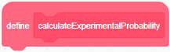).
When the file opens, there is no code in this block.
Follow these steps to create the code for this block.
- Start by writing code to calculate the experimental probability
of tossing two heads. Store this number in a variable called experimentalProbability-HH that has already been created.
- To do this, under Variables, select the set block and place it beneath the define calculateExperimentalProbability.
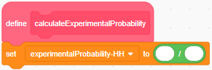
- Ensure the experimentalProbability-HH
variable is selected from the pulldown menu.
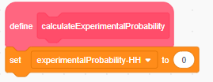
- Under Operators, select the division
operator (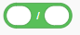) and place it inside
the set block.
- From Variables, drag the HH variable block inside the first part
of the division operator.
Drag the totalTosses variable block inside the second part
of the division operator.
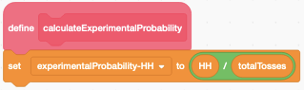
Writing and Altering Code
for a Coin Toss Simulator (cont’d)

Algebra
Unit 3 Line Master 8d

- Repeat this process by adding additional set blocks and division operators to this subprogram for:
experimentalProbability-TT
experimentalProbability-HTorTH
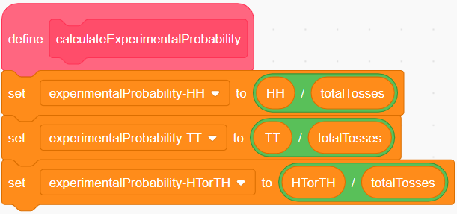
Notice that the calculateExperimentalProbability block
is inside the repeat.
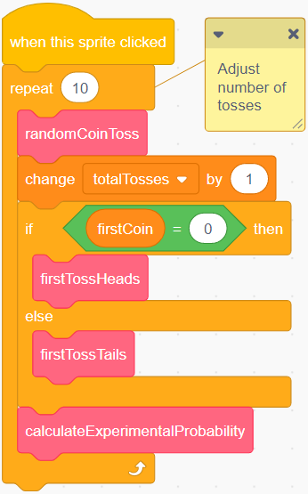
This means that it will calculate
the experimental probability
with each toss as the code is executed.
Record the experimental probability
for 10 trials.

Writing and Altering Code
for a Coin Toss Simulator (cont’d)

Algebra
Unit 3 Line Master 8e

5. Test your new code.
- Change the wait time to 0 in the randomCoinToss
subprogram.
- Alter the repeat value to 1000.
- Click on the green flag to reset the variables, then click
on the Toss button to execute the code.
- Check that the numbers are close to what you expected
based on the theoretical probability of tossing two coins
many times.
If the numbers seem wrong, look through your code to identify
any errors.

Writing and Altering Code
for a Coin Toss Simulator (cont’d)

Algebra
Unit 3 Line Master 8f

6. Alter the code to do a large number of trials.
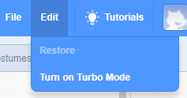
- First, turn on Turbo Mode so that
you don’t have to wait for the results.
Under Edit, select Turn on Turbo Mode.
You will know that Turbo Mode is on
because it will indicate this above the Stage.
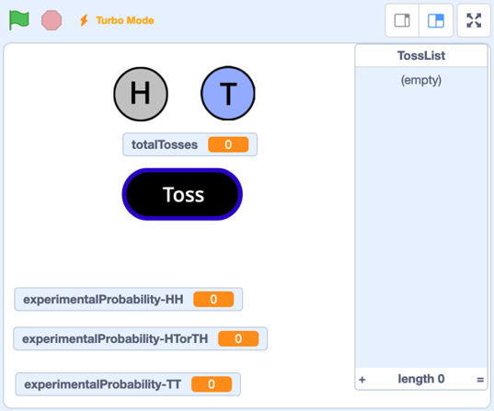
- Click on the green flag to reset the variables.
- Alter the repeat value to 10 000.
What are the experimental probabilities for each event?
- Alter the repeat value to 1 000 000. Compare the expermental probability to the value you recorded for 10 trials.
Explain why the numbers are different.

