Answers

Algebra
Unit 3 Line Master 8g

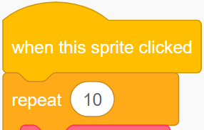
1. The repeat number indicates
how many tosses will be simulated.
2. A 0 is used to represent heads and a 1 to represent tails.
3. To toss the coins faster, change the wait time to less than
0.5 s.
4. The finished code for the subprogram calculateExperimentalProbability should look like this:
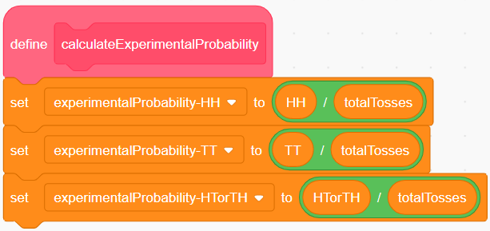
5. The experimental probabilities will vary but will likely be
reasonably close to the theoretical probabilities,
which are HH: $\frac{1}{4}$, TT: $\frac{1}{4}$, HT or TH: $\frac{1}{2}$.

6. The experimental probabilities for 1 000 000 trials are closer to the theoretical probabilities than the results for 10 trials. When you have only 10 trials, getting the same outcome a few times in a row can have a big effect on the probabilities. Usually, the more trials we simulate, the closer the experimental probabilities get to the theoretical probabilities.

