Data Analysis and
Hours of Screen Time

Algebra
Unit 3 Line Master 7a

Start with the Hours of Sleep application that you created
for Master 5 a–i. Here’s a version of that application if you
didn’t save yours:
https://scratch.mit.edu/projects/702954542/editor
Remember: you must be logged in to save your work in your
Scratch account.
Here are some tips for creating the Hours of Screen Time application.
- If you alter the previous code, rename the variables instead of creating new ones.
To do this, go to Variables, right click on a variable, and select Rename variable.
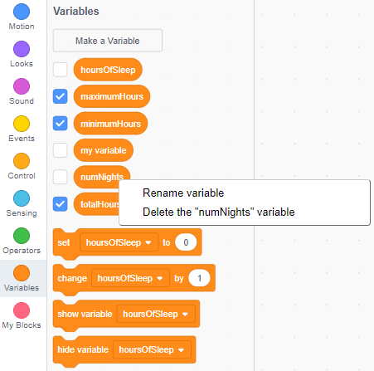
- Name your variables using
descriptive terms.
For example, replace numNights
with numDays, and hoursOfSleep
with hoursOfScreenTime.

- Select a relevant Backdrop or create/upload your own.

Data Analysis and
Hours of Screen Time (cont’d)

Algebra
Unit 3 Line Master 7b

Extensions:
- Allow the user to change the number of days for
which they’d like to input data.
- Provide feedback to the user based on their data.
- For example, if their mean screen time is greater
than 5 h per day, provide tips to reduce the number
of hours.
- Or share information about the negative effects
of spending too much time on screens.
Conditional statements are helpful for this.
- Create a list called userData and use it to store
and display the user’s input.
- Incorporate additional subprograms in your application.

