Guided Materials in Scratch:
Data Analysis and Sleep

Algebra
Unit 3 Line Master 6a

Part 1: Determining the minimum number of hours slept
in one week
Read the code.
Execute the code by clicking on the green flag .
To test the application, enter these numbers, one at a time,
with a return after each entry:
8
7
6
9
8
7
8
Did the application output the least number from the list?

Part 2: Determining the maximum number of hours slept
in one week
Create another variable called maximumHours.
1. Go to Variables and select Make a Variable.
Call it maximumHours and select OK.
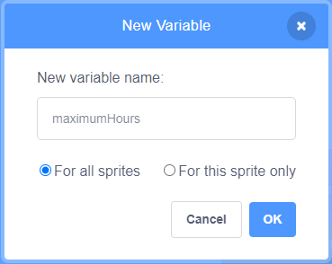
Guided Materials in Scratch:
Data Analysis and Sleep
(cont’d)

Algebra
Unit 3 Line Master 6b

2. Add a set block to the end of the resetVariables subprogram.
Ensure maximumHours is selected in the pulldown menu
and that it’s set to 0.
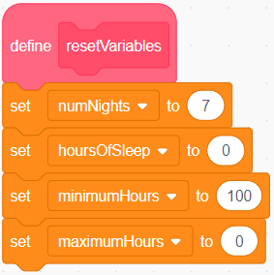
3. Under Control, select an if () then block and place it inside
the repeat block after the first if () then block.
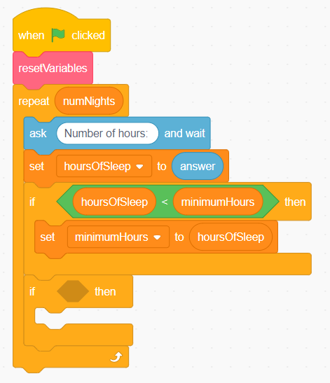

Guided Materials in Scratch:
Data Analysis and Sleep
(cont’d)

Algebra
Unit 3 Line Master 6c

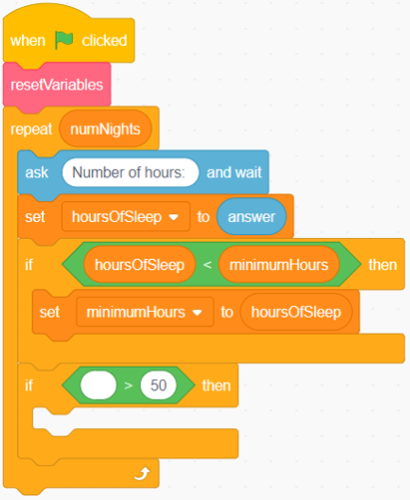
4. Under Operators, select a
greater than operator block.
Place it inside the condition area
of the if () then block.

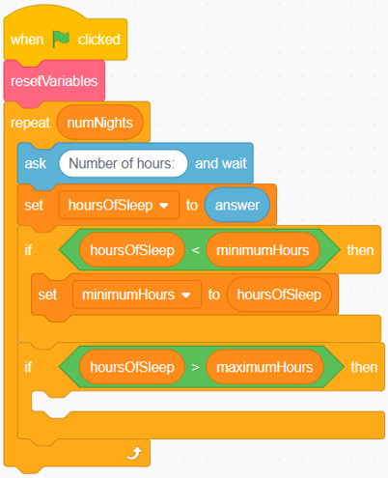
5. From Variables, place the
hoursOfSleep block inside
the first part of the conditional
operator, and the maximumHours
block inside the second part of the
conditional operator.

Guided Materials in Scratch:
Data Analysis and Sleep
(cont’d)

Algebra
Unit 3 Line Master 6d

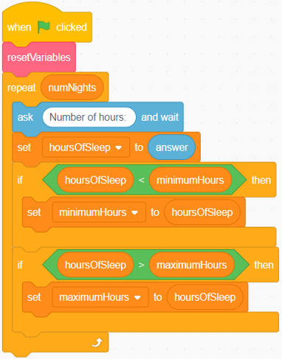
6. Place a set block inside the
conditional statement and ensure
maximumHours is selected from
the pulldown menu.
Place the hoursOfSleep block
inside the set block.

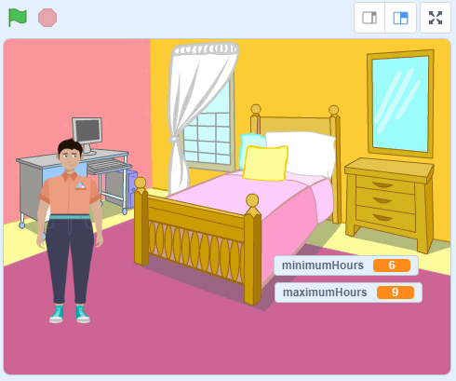
7. On the Stage, move the
maximumHours variable beneath
the minimumHours variable.

8. Test the application by clicking the green flag and entering the
same list of numbers from earlier, or 7 numbers of your choice.
Is the greatest number displayed in the maximumHours variable
on the Stage?
Data Analysis and Hours of Sleep
(cont’d)

Patterning and Algebra
Unit 2 Line Master 5e
Guided Materials in Scratch:
Data Analysis and Sleep
(cont’d)

Algebra
Unit 3 Line Master 6e

Part 3: Determining the total number of hours slept in one week
1. Under Variables, select Make a Variable and call it totalHours.
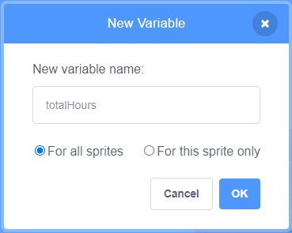
2. Place a new set block at the end of the resetVariables
subprogram.
Ensure the totalHours variable is selected from the
pulldown menu and that it’s set to 0.
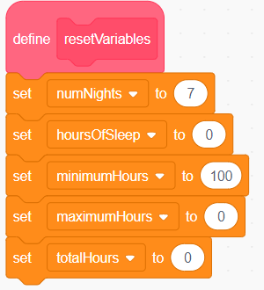
Data Analysis and Hours of Sleep
(cont’d)

Patterning and Algebra
Unit 2 Line Master 5e
Guided Materials in Scratch:
Data Analysis and Sleep
(cont’d)

Algebra
Unit 3 Line Master 6f

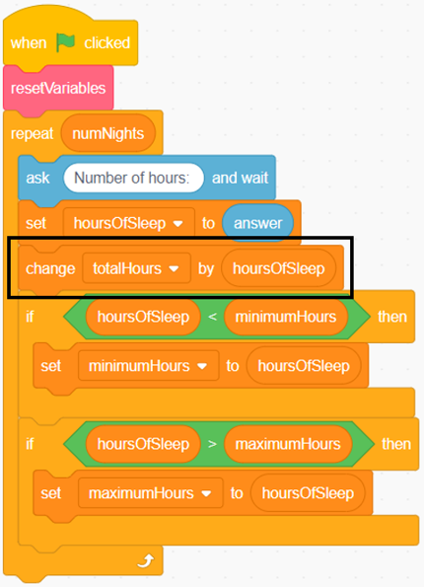
3. Drag a change block inside the
repeat block just before the first
if () then block.
Ensure totalHours is selected
from the pull-down menu.
Place an hoursOfSleep block
inside the change block.

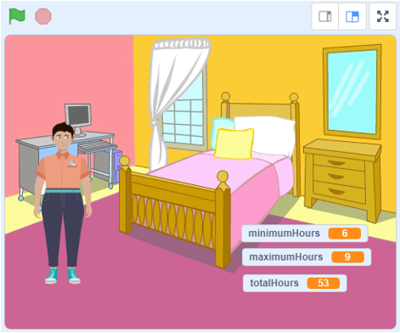
4. On the Stage, move the totalHours
variable beneath the other two
variables. Execute the code and test
the application.
Does the code provide the sum
of the numbers you entered?
If not, look carefully at the code
to check for any errors.
Data Analysis and Hours of Sleep
(cont’d)

Patterning and Algebra
Unit 2 Line Master 5e
Guided Materials in Scratch:
Data Analysis and Sleep
(cont’d)

Algebra
Unit 3 Line Master 6g

Part 4: Determining the mean number of hours of sleep
in one week
1. From Variables, select Make a Variable and call it meanHours.
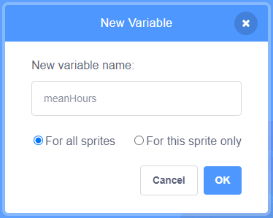
2. Drag a set block to the end of the resetVariables subprogram.
Ensure the meanHours variable is selected from the pulldown
menu, and that it’s set to 0.
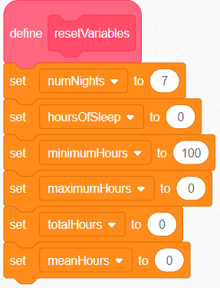

Data Analysis and Hours of Sleep
(cont’d)

Patterning and Algebra
Unit 2 Line Master 5e
Guided Materials in Scratch:
Data Analysis and Sleep
(cont’d)

Algebra
Unit 3 Line Master 6h

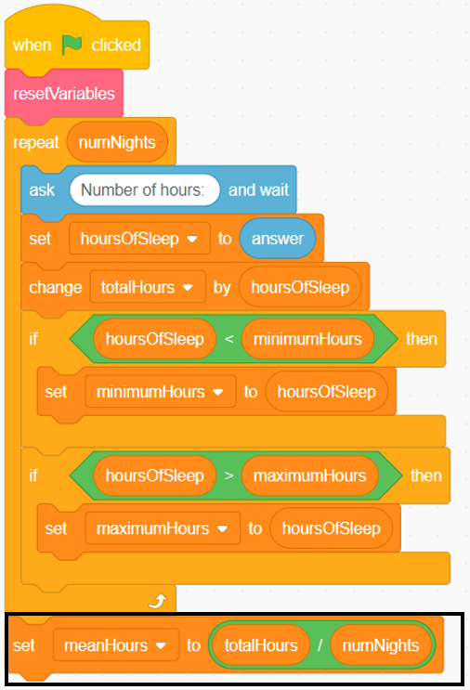
3. Drag a set block to the end
of the repeat block.
Ensure the meanHours block
is selected from the pulldown menu.
From Operators, drag a division
operator inside the set block.
From Variables, drag the totalHours
block inside the first part of the
division operator. Drag the
numNights block inside the second
part of the division operator.

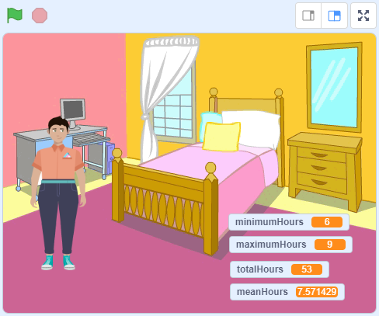
4. On the Stage, move the meanHours variable beneath the other
variables. Execute the code to test your program.

