Answers

Algebra
Unit 3 Line Master 5j

Part 1: Determining the minimum number of hours slept
in one week
Yes, the program outputs the minimum number of hours for
this set of data, which is 6 h.
Part 2: Determining the maximum number of hours slept
in one week
Pseudocode for this is provided in the hints at the end of
the Master.
Sample code after this step is shown here, with the added
blocks outlined in black:
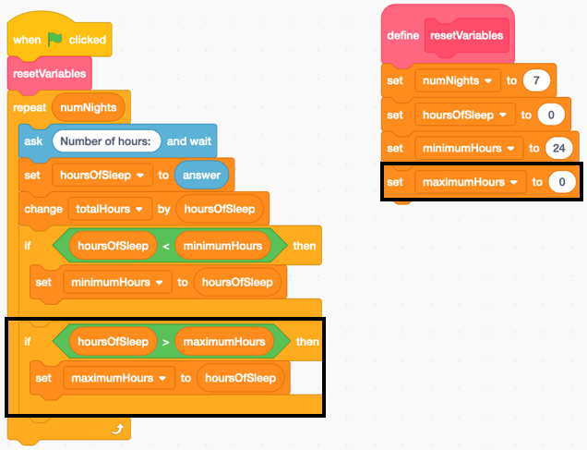
The program outputs the minimum and maximum number
of hours for this set of data. The maximum is 9 h.
Answers (cont’d)

Algebra
Unit 3 Line Master 5k

Part 3: Determining the total number of hours slept
in one week
Pseudocode for this is provided in the hints at the end of
the Master.
Sample code after this step is shown here, with the added
block outlined in black:
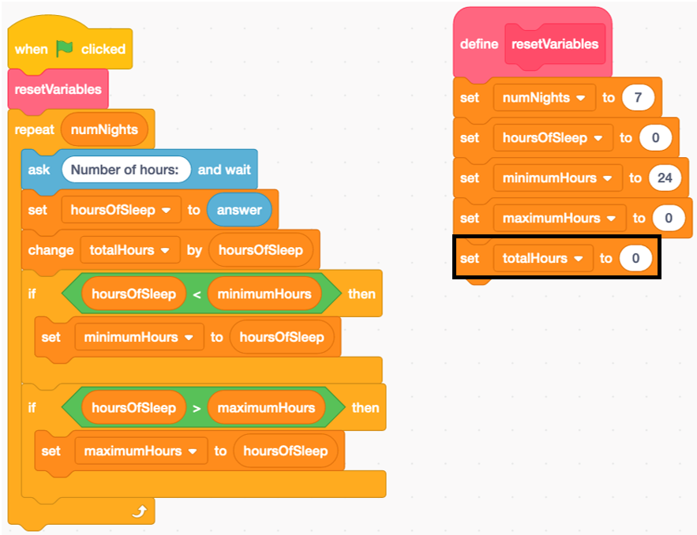
The program outputs the minimum, maximum, and total number of hours for this set of data. The total is 53 h.

Answers (cont’d)

Algebra
Unit 3 Line Master 5l

Part 4: Determining the mean number of hours slept
in one week
Pseudocode for this is provided in the hints at the end of
the Master.
Sample code after this step is shown here, with the added blocks outlined in black:
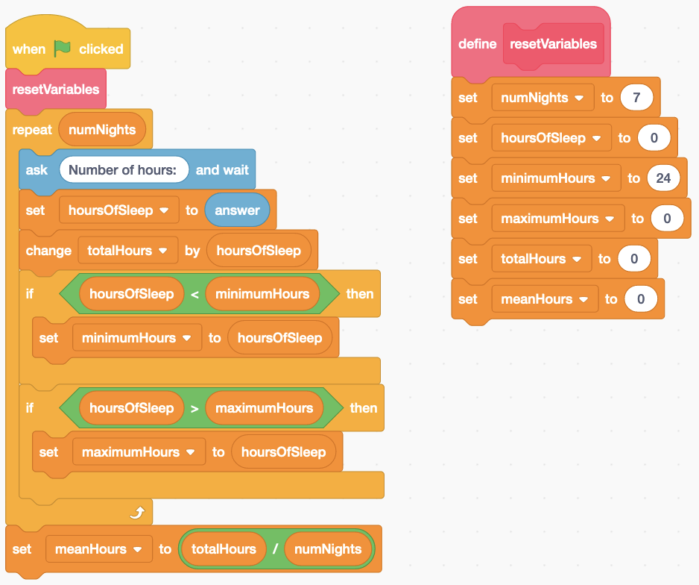
The program outputs the minimum, maximum, total, and mean number of hours for this set of data. The mean is 7.571429
or about 7.6 h.

Answers (cont’d)

Algebra
Unit 3 Line Master 5m

Extensions:
Sample answers for the first and fourth suggested extension are provided below.
The other extensions are more open and student responses may vary greatly.
- To allow the user to indicate the number of nights of data, students could add these blocks to the main program just after the Reset Variables subprogram is called.
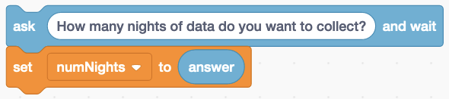
- Once a list called userData has been created, a block can
be added to the code before the repeat to empty previously saved data and another block can be added within the repeat to add the user’s responses to the list. I moved the list of data to a place on the stage where it wouldn’t cover an important part of the picture. Sample code and a sample list are
shown below.
