Yindi’s Labels—Online Order Form

Algebra
Unit 3 Line Master 4a

Here is a link to the partially completed Scratch application
Yindi created for her clients.
https://scratch.mit.edu/projects/718912470/editor/
Remember: You must be logged in to save your work in your
Scratch account.
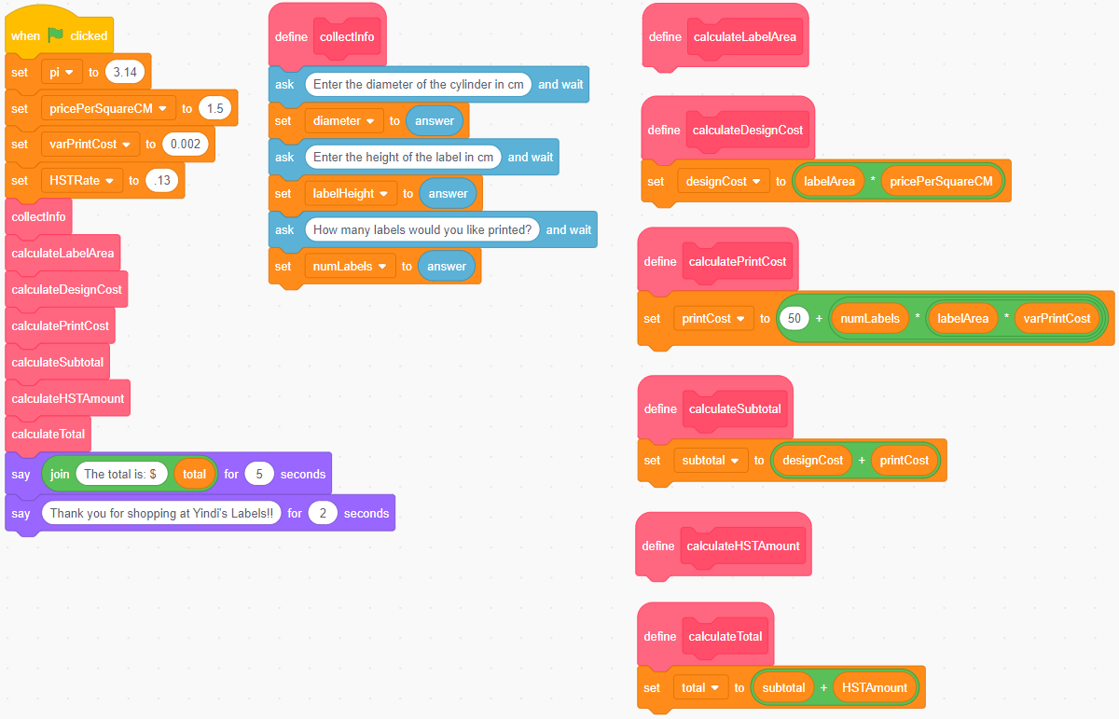
The code is shown below:

Yindi’s Labels—Online Order Form
(cont’d)

Algebra
Unit 3 Line Master 4b

1. What 3 pieces of information is the user asked to enter?
2. Once the code has been completed, what 5 pieces of information
will the application calculate and display?

Here is a sample of what will appear on the stage after the code
is completed and a client has entered their data:
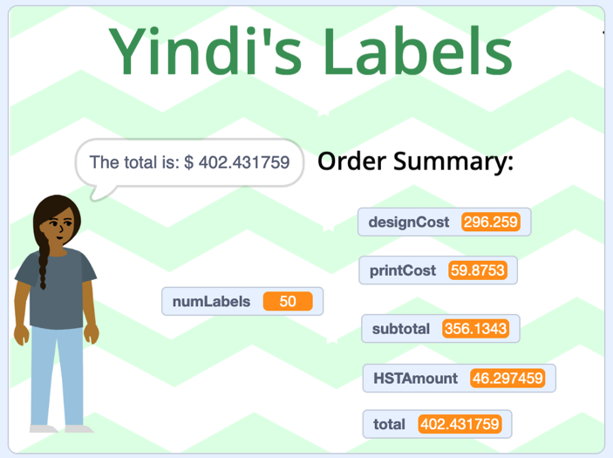
Yindi’s Labels—Online Order Form
(cont’d)

Algebra
Unit 3 Line Master 4c

Pseudocode has also been partially written for this application:
subprogram collectInfo
output “Enter the diameter of the cylinder in cm”
store user input as diameter
output “Enter the height of the label in cm”
store user input as labelHeight
output “Enter the number of labels you would like printed”
store user input as numLabels

subprogram calculateLabelArea
labelArea = pi * diameter * labelHeight

subprogram calculateDesignCost
designCost = labelArea * pricePerSquareCM

subprogram calculatePrintCost
printCost = 50 + numLabels * labelArea * varPrintCost

subprogram calculateSubtotal
#complete this

subprogram calculateHSTAmount
HSTAmount = HSTrate * subtotal
display HSTAmount

subprogram calculateTotal
#complete this

#Main program
pi = 3.14
pricePerSquareCM = 1.50
varPrintCost = 0.001
run subprogram collectInfo
run subprogram calculateLabelArea
run subprogram calculateDesignCost
Yindi’s Labels—Online Order Form
(cont’d)

Algebra
Unit 3 Line Master 4d

run subprogram calculatePrintCost
run subprogram calculateSubtotal
run subprogram calculateHSTAmount
run subprogram calculateTotal

output “The total is: $”, total
3. Identify the following data used in the application:
a) What does the pricePerSquareCM variable represent?
What is the value of this variable when the program opens?
b) What does the varPrintCost variable represent?
What is the value of this variable when the program opens?
4. Complete the Scratch application by:
a) Writing the code for the calculateLabelArea subprogram
b) Writing the code for the calculateHSTAmount subprogram
5. Complete the pseudocode by:
a) Writing the pseudocode for the calculateSubtotal
b) Writing the pseudocode for the calculateTotal application
Hints:
- Use the partially completed pseudocode to help you complete
the code in Scratch.
- Use several multiplier operators inserted into one another
to calculate the area of the label.

Yindi’s Labels—Online Order Form
(cont’d)

Algebra
Unit 3 Line Master 4e

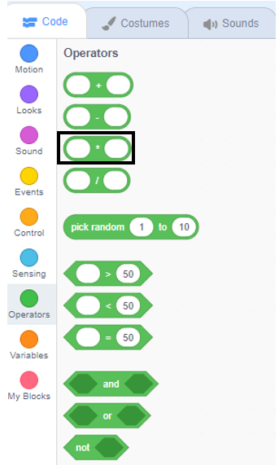
- Use the partially completed Scratch application to help you complete the pseudocode.
Extensions:
- Provide different varPrintCost rates for the labels based on
bulk purchases.
For example, if the user orders 500 to 999 labels, they get
a reduced rate.
If they order at least 1000 labels, they get an even greater reduction.
Hint: Conditional Statements would work for this.
- Alter the code to ensure the variables that represent the subtotal, HSTAmount, and total only contain two decimal places.
This is trickier than it sounds!

