Answers

Algebra
Unit 3 Line Master 4f

1. The user is asked to enter the diameter of the container,
the label height, and the number of labels they want printed.
2. Once completed, the application will calculate and display the design cost, printing cost, subtotal, tax, and total.
3. a) The cost per square centimetre to design a label;
$1.50 per square centimetre
b) The cost per label to print the labels;
$0.002, or 0.2¢ per label.
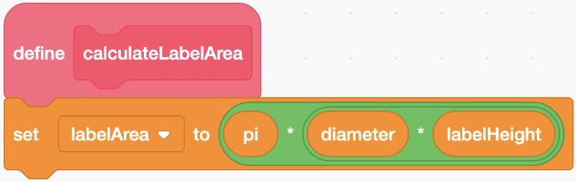
4. a)

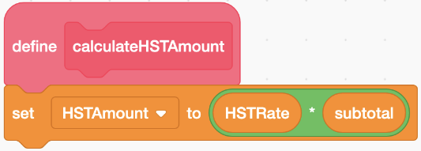
b)

5. a) subprogram calculateSubtotal
subtotal = DesignCost + PrintCost
b) subprogram calculateTotal
Total = subtotal + HSTAmount

Answers (cont’d)

Algebra
Unit 3 Line Master 4g

Extensions:
Sample answers:
- I decided to make the rate per label $0.0015 (0.15¢)
for orders between 500 and 999 labels and $0.001 (0.1¢)
for orders of 1000 or more labels. This is how I changed
the subprogram that calculates the print cost:
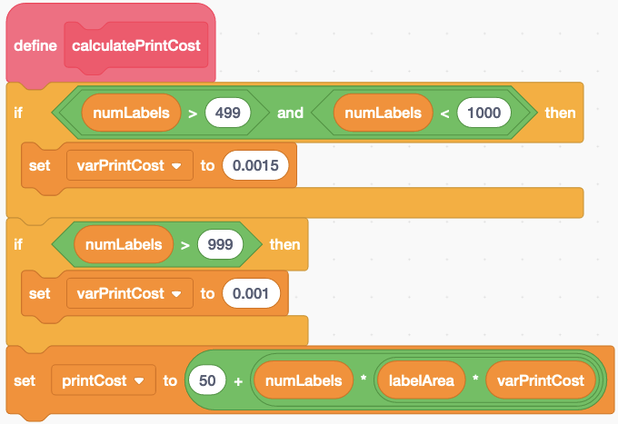
- I added a block to the end of each of the subtotal and
HST amount subprograms.
One new block multiplies the subtotal variable by 100,
rounds it, then divides by 100.
One new block multiplies the HSTAmount variable by 100, rounds it, then divides by 100.
Because the total is calculated by adding these two variables, it will also be calculated to 2 decimal places.

Answers (cont’d)

Algebra
Unit 3 Line Master 4h

The subprograms look like this:
