Yindi’s Labels—Design Quote

Algebra
Unit 3 Line Master 3a

Check out the Design Quote application created in Scratch here:
https://scratch.mit.edu/projects/718910000/editor/
If you have a Scratch login, save the project in your Scratch account by selecting Remix at the top of the screen.
A login is not required to work with the code, but you will not be able to save your changes without it.
The code is shown below:
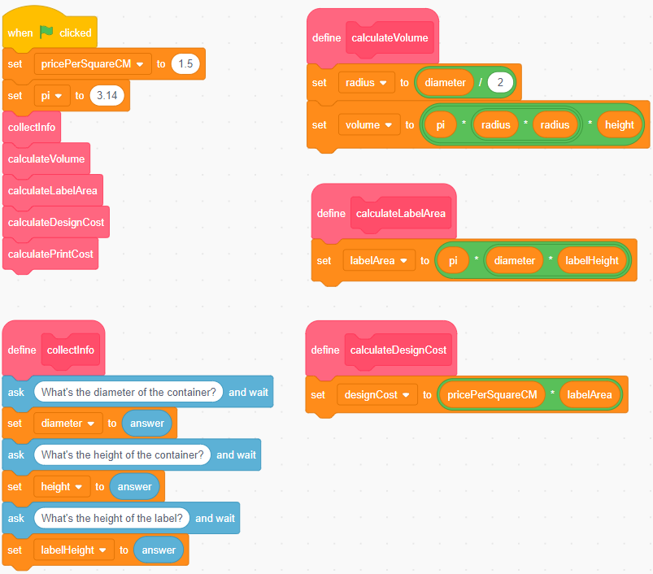

Yindi’s Labels—Design Quote (cont’d)

Algebra
Unit 3 Line Master 3b

Because the label may be shorter than the container,
Yindi requests both the container height and label height.
The user clicks on the green flag ( ), then types the diameter, height, and label height in centimetres in response to the questions.
The dimensions as well as the container volume, area of the label, and cost to design the label are displayed on the stage.
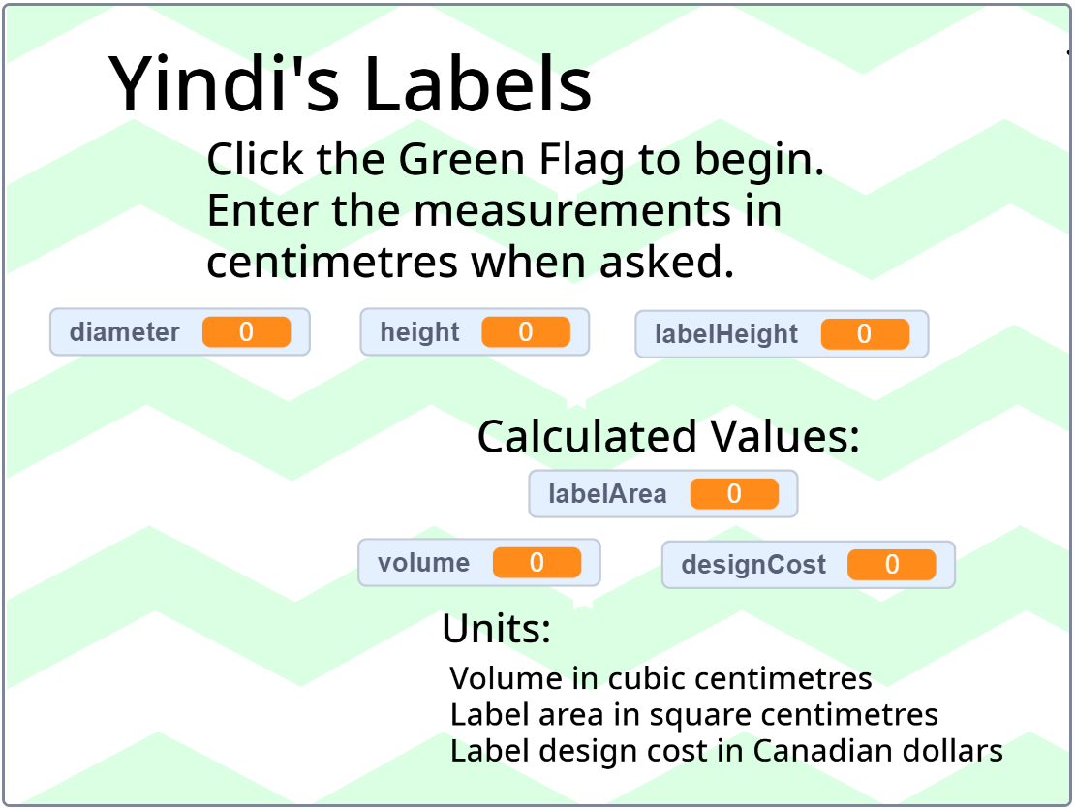
Yindi used subprograms to collect data from the client, and to calculate the volume, the area of the label, and the cost to design it.
Coding Vocabulary Check
Pseudocode is an informal way of describing a computer program; computer programmers, or coders, often use pseudocode when planning their programs.
A subprogram is a set of instructions for completing a specific task; a subprogram can be referenced and called to action by the main program to accomplish a large task using small steps.
In coding, a variable has a value that may change throughout a program and may include text, characters, or numbers.

Yindi’s Labels—Design Quote (cont’d)

Algebra
Unit 3 Line Master 3c

Here is the pseudocode for this application:
subprogram collectInfo
ask for the container diameter
ask for the container height
ask for the label height

subprogram calculateVolume
radius = diameter / 2
volume = pi * radius * radius * height
display volume

subprogram calculateLabelArea
labelArea = pi * diameter * labelHeight
display labelArea

subprogram calculateLabelCost
labelCost = pricePerSquareCM * labelArea
display labelCost

#Main program
pricePerSquareCM = 1.50
pi = 3.14
run subprogram collectInfo
run subprogram calculateVolume
run subprogram calculateLabelArea
run subprogram calculateLabelCost

Yindi’s Labels—Design Quote (cont’d)

Algebra
Unit 3 Line Master 3d

Use the pseudocode and/or the Scratch application to answer
the questions below.

1. The client enters a height and label height of 10 cm,
and a diameter of 6.5 cm.
What volume, label area, and label design cost are displayed?
2. A client is deciding between these dimensions for a cylindrical jar.
- diameter: 8 cm; height: 11.8 cm; label height: 6.8 cm
- diameter: 7.4 cm; height: 13.5 cm; label height: 8.5 cm
a) How do the volumes of the jars compare?
b) Which jar would have a cheaper label design cost?
3. Yindi changes their label design pricing to $1.25/cm².
How would you alter the code to reflect this change?
4. Suppose Yindi changes the first question asked so the user
inputs the radius instead of the diameter.
How would the pseudocode be altered to reflect this change?
5. Yindi adds two subprograms as described below.
Write code for the two subprograms.
a) to calculate the surface area of the top of the
cylindrical container
b) to calculate the cost of designing a circular sticker
for the top of the container
If you want some help, check out the Hints below.
Hints:
- Write the pseudocode before coding in Scratch
- You will need to include two more variables; call them topSA
and topStickerCost.
- Call the subprograms you create: calculateTopSA; calculateTopStickerCost.
Yindi’s Labels—Design Quote (cont’d)

Algebra
Unit 3 Line Master 3e

Extensions:
- Have a character “say” the label design cost with a speech bubble:
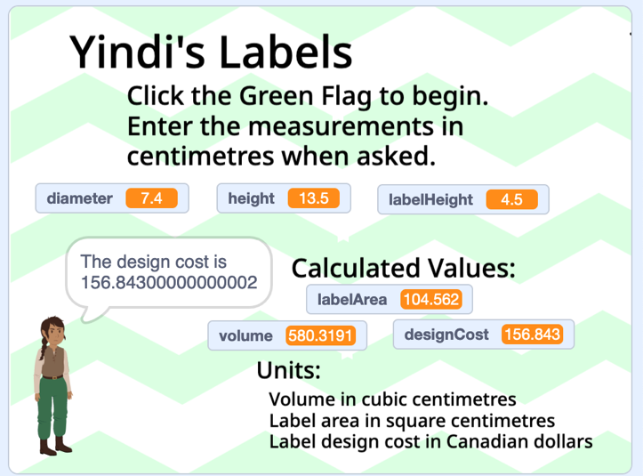
- Alter the code to ensure the designCost variable only contains two decimal places. This is trickier than it sounds!
- Measure the diameter, height, and label height of some grocery items packaged in cans or other cylindrical containers.
Use the app to verify that the volume is large enough to hold the amount of product specified on the label. (Hint: 1 cm³ = 1 mL)
How much would Yindi charge to design a label for each product?
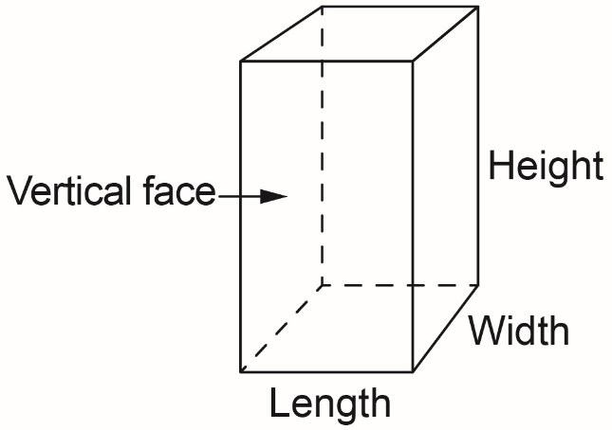
- Create an application to calculate
the volume of a rectangular prism.
Determine the cost to design a label
that can be wrapped around the
four faces (not the top and
bottom faces).

