The Transformation Turtle:
Translating to All Four Quadrants

Algebra
Unit 3 Line Master 2a

Click on this link to access the Scratch application:
https://scratch.mit.edu/projects/708228126/editor/
Remember: You must be logged in if you want to save your work
in your Scratch account.
A login is not required to work with the code, but you will not
be able to save your changes without it.
Look at the code in the original application, shown below.
In the translation subprogram, the turtle starts at the point (0, 0),
since the go to block contains the values 0 for x and 0 for y.
This is the centre of the stage.
The translation subprogram then translates the turtle to various random positions on the Cartesian plane.
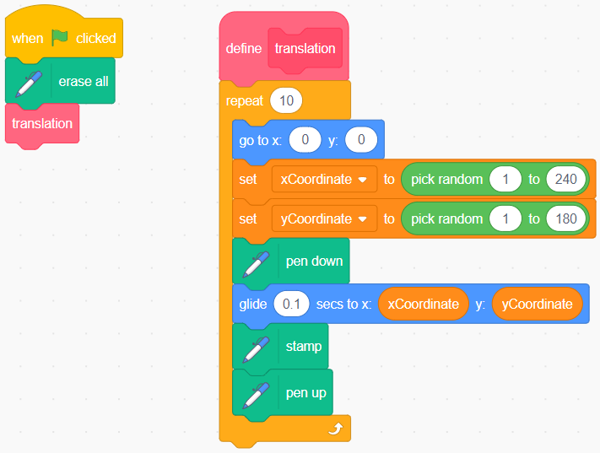
The range values for both the xCoordinate and yCoordinate variables are positive integers.
This means that the turtle will always move to the right and up
from the starting point (0, 0) to a point in Quadrant 1.
The Transformation Turtle:
Translating to All Four Quadrants
(cont’d)

Algebra
Unit 3 Line Master 2b

Click on the green flag a few times to execute the code to see
where the turtles are stamped each time.
They should always be stamped in Quadrant 1.
Change the number of seconds in the glide block to 0.1.
Follow the instructions below to alter the code to translate the turtle
to Quadrants 2, 3, and 4.
1. Label each quadrant as Q1, Q2, Q3, and Q4 on the image below.
Hint: Start by labelling the upper right quadrant as Q1 and moving
counterclockwise to each of the other quadrants.
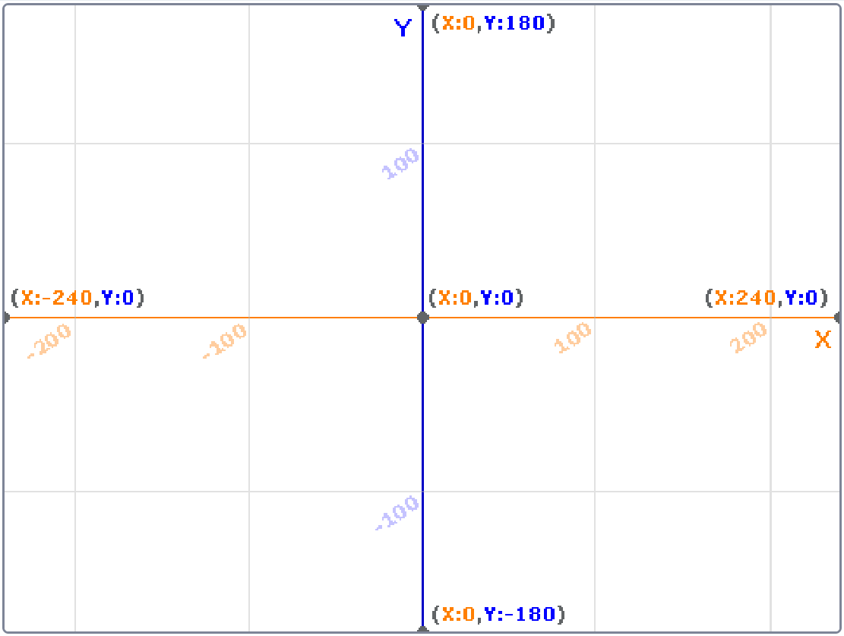

The Transformation Turtle:
Translating to All Four Quadrants
(cont’d)

Algebra
Unit 3 Line Master 2c

2. Alter the code as shown below by changing the random value
range for the xCoordinate variable to −240 to −1.
a) Before clicking on the green flag to execute the code,
predict how the turtles will move.
Will they move left or right?
Will they move up or down?
In which quadrant will the turtles be stamped?
Explain your predictions.
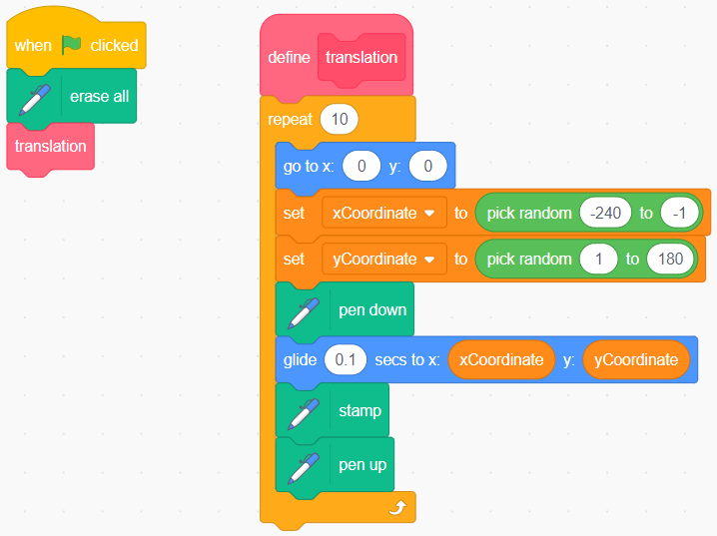
b) Were your predictions correct? Explain.

The Transformation Turtle:
Translating to All Four Quadrants
(cont’d)

Algebra
Unit 3 Line Master 2d

3. Alter the code so the turtle will be translated to and stamped
anywhere in Quadrant 1 or 2, as shown below.
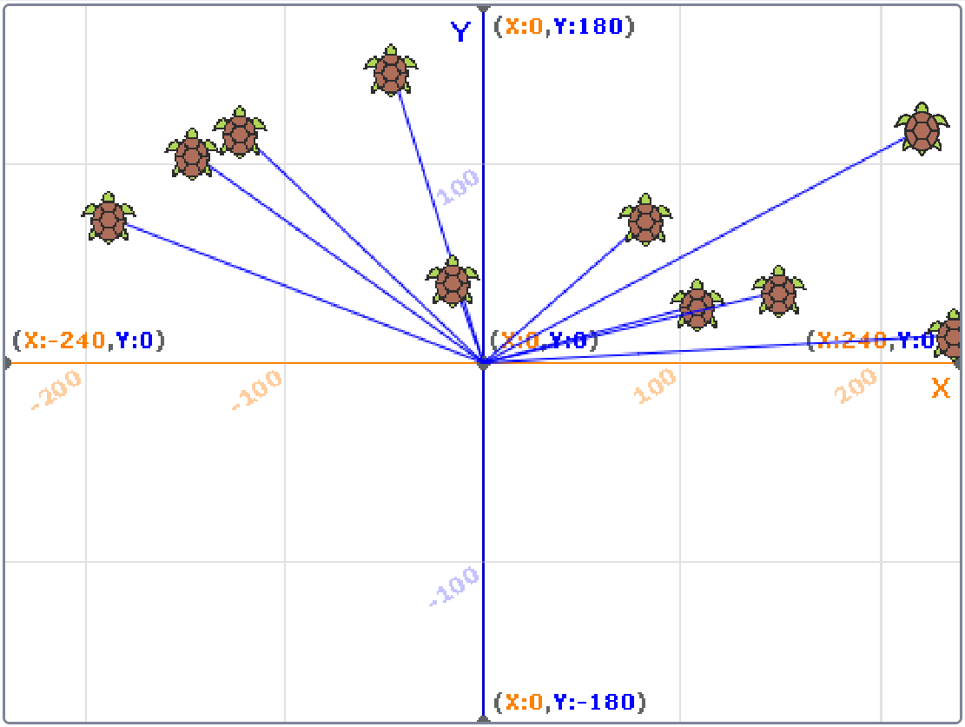
Try a few times. If you get stuck, use the hint below.
Hint: Change the random value range of the xCoordinate variable
to –240 to 240. This assigns random numbers between –240 and
240 to the xCoordinate—a range that includes the whole x-axis
of this grid.
The Transformation Turtle:
Translating to All Four Quadrants
(cont’d)

Algebra
Unit 3 Line Master 2e

4. Alter the code as shown below.
The random value range for the xCoordinate variable is 1 to 240.
The yCoordinate variable random value range is −180 to −1.
a) Before clicking on the green flag to execute the code,
predict how the turtles will move.
Will they move left or right?
Will they move up or down?
In which quadrant will the turtles be stamped?
Explain your predictions.
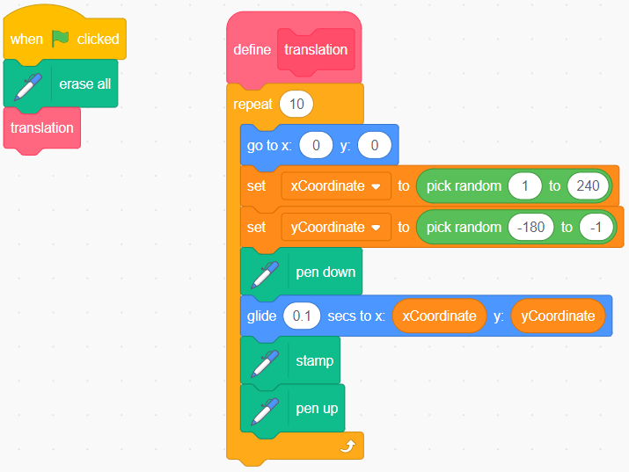
b) Were your predictions correct? Explain.

The Transformation Turtle:
Translating to All Four Quadrants
(cont’d)

Algebra
Unit 3 Line Master 2f

5. Alter the code so the turtles will be translated to and stamped
in Quadrant 1 or 4, as shown below.
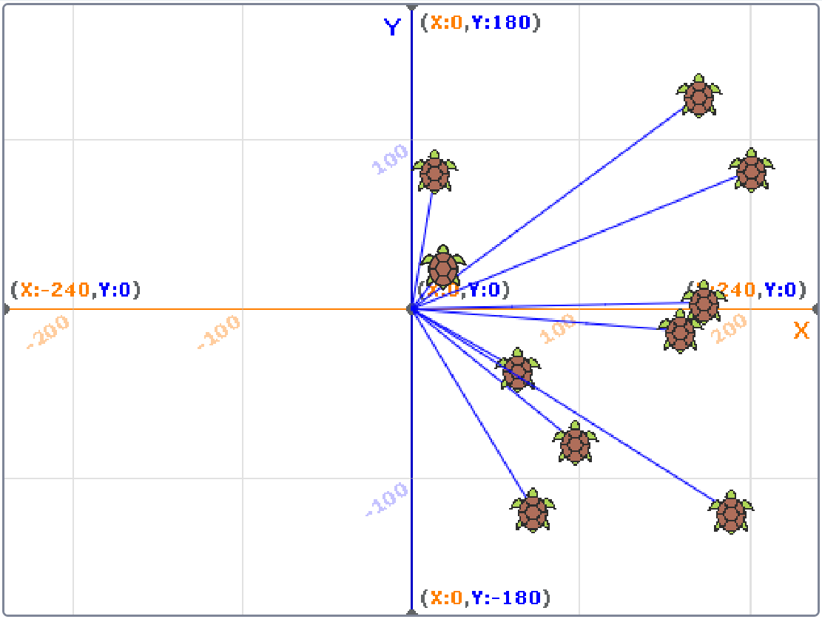
Try a few times. If you get stuck, use the hint below.
Hint: Change the random value range of the yCoordinate variable
to −180 to 180. This assigns random numbers between −180 and
180 to the yCoordinate—a range that includes the whole y-axis
of this grid.

The Transformation Turtle:
Translating to All Four Quadrants
(cont’d)

Algebra
Unit 3 Line Master 2g

6. Alter the code as shown below.
The random value range for the xCoordinate variable
is −240 to −1.
The yCoordinate variable random value range is −180 to −1.
a) Before clicking on the green flag to execute the code,
predict how the turtles will move.
Will they move left or right?
Will they move up or down?
In which quadrant will the turtles be stamped?
Explain your predictions.
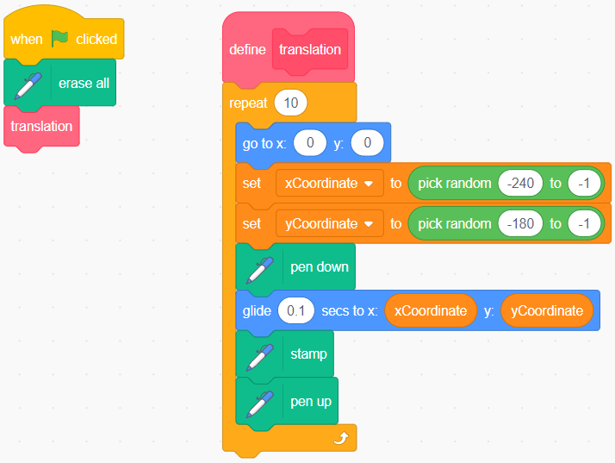
b) Were your predictions correct? Explain.

The Transformation Turtle:
Translating to All Four Quadrants
(cont’d)

Algebra
Unit 3 Line Master 2h

7. Alter the code so the turtle is translated to and stamped
in any of the four quadrants.
Change the repeat to 40 so more turtles are stamped,
as shown below.
