Answers

Algebra
Unit 3 Line Master 2i

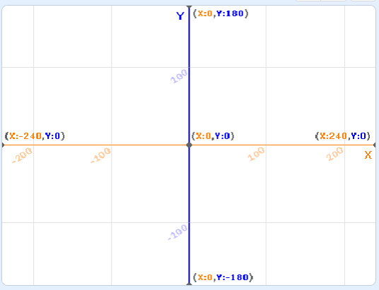
1.
Q1
Q2
Q4
Q3

Sample answers:
2. a) I think the turtles will move left because the x-coordinates
will be negative.
I think they will move up because the y-coordinates
will be positive.
This means the turtles will be stamped in Quadrant 2.
b) My predictions were correct.
Sample stage output:
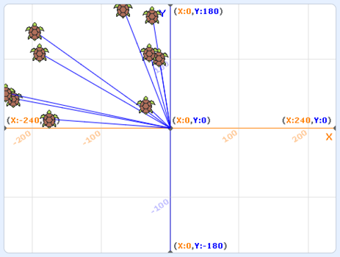
3. I left the y-coordinate range as 1 to 180.
I changed the x-coordinate range to −240 to 240.
Answers (cont’d)

Algebra
Unit 3 Line Master 2j

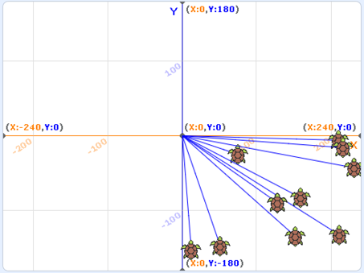
4. a) I think the turtles will move right because the x-coordinates
will be positive.
I think they will move down because the y-coordinates
will be negative.
This means the turtles will be stamped in Quadrant 4.
b) My predictions were correct.
Sample stage output:

5. I left the x-coordinate range as 1 to 240.
I changed the y-coordinate range to −180 to 180.
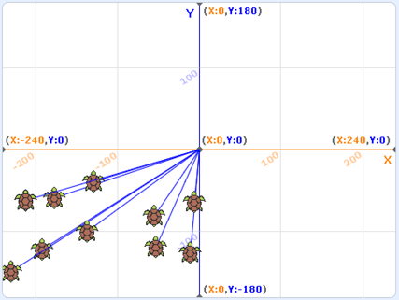
6. a) I think the turtles will move left because the x-coordinates
will be negative.
I think they will move down because the y-coordinates
will be negative.
This means the turtles will be stamped in Quadrant 3.
b) My predictions were correct.
Sample stage output:

7. I set the x-coordinate range to −240 to 240 and the y-coordinate
range to −180 to 180.

