Coin Toss Simulator Challenges
Graphing with Google Sheets

Algebra
Unit 3 Line Master 11a

Follow these instructions to import and graph data in Google Sheets.

- Open a Blank new Spreadsheet in Google Sheets.
- Select File, Import.
- Locate and select the TossCombo file.
- Select Import data.
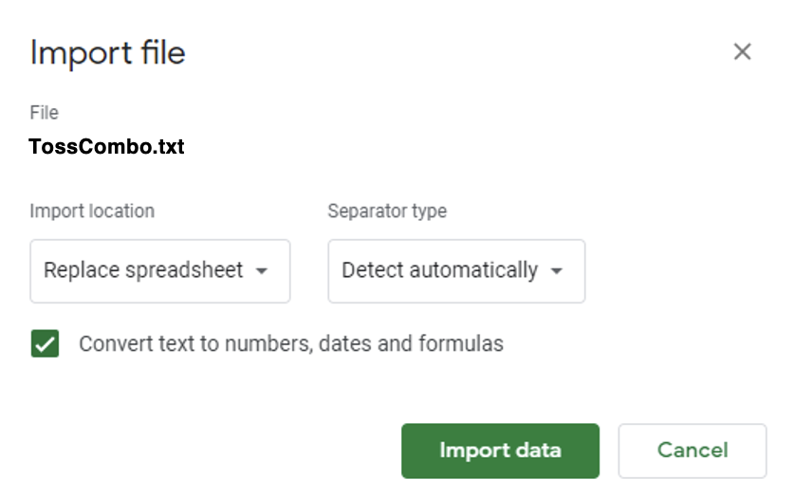
5. Select Import data.

Coin Toss Simulator Challenges
Graphing with Google Sheets (cont’d)

Algebra
Unit 3 Line Master 11b

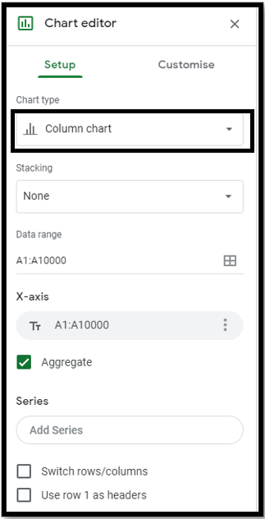
6. Click on the chart. In the Chart editor,
click on the pulldown menu for
Chart type and select Column chart.
You may have to right click on the chart
and select Chart style if you don’t see
the correct window.

7. You’ve made a chart!
Change the Title text for the chart.
Adjust the colour if you wish.
A sample is shown here.
