Coin Toss Simulator Challenges
Graphing with Microsoft Excel

Algebra
Unit 3 Line Master 10a

Instructions for importing data and graphing in Microsoft Excel
for the PC:
1. Open a Blank workbook in Excel.
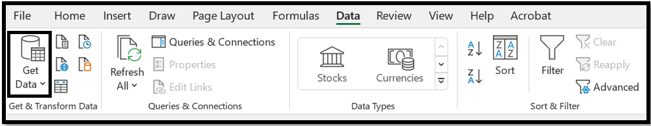
2. Select Data, Get Data.

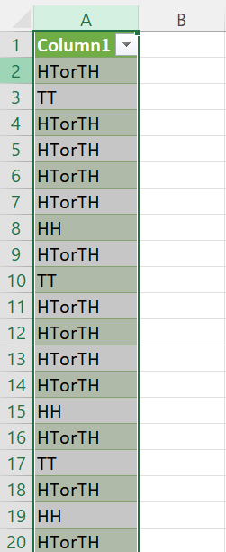
3. Select From File, From Text/CSV.
4. Locate your TossCombo file and select Import.
5. Select Load.
6. Click on Column A, so the Column is selected.
7. Select Insert, Recommended Charts.

Coin Toss Simulator Challenges
Graphing with Microsoft Excel (cont’d)

Algebra
Unit 3 Line Master 10b

8. Click on OK.
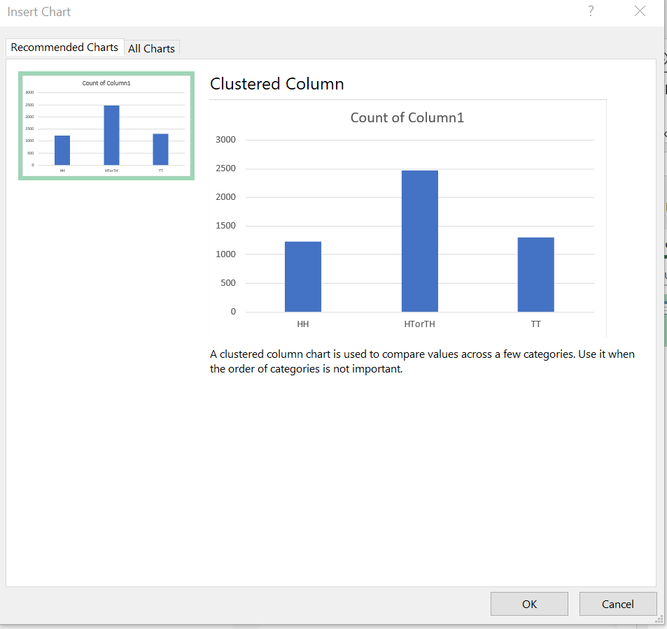
9. You’ve made a chart!
Adjust the title and colour as you see fit.
A sample is shown here.
