The Transformation Turtle:
Translating with Code and Making Predictions

Algebra
Unit 3 Line Master 1a

Click on this link to access the Scratch application:
https://scratch.mit.edu/projects/708228126/editor/
If you have a Scratch login, save the project in your Scratch
account by selecting Remix at the top of the screen.
A login is not required to work with the code, but you will not
be able to save your changes without it.

Part 1: Exploring the Code
1. Click on the green flag ( ) to execute the code.
a) How many turtles are stamped on the grid?
b) Where does the turtle begin each journey on the grid?
How do you know?
c) In which quadrant is the turtle image stamped each time?
d) What does each blue line show?
e) What do all the blue lines have in common?

2. In the code, there is a subprogram called translation.
a) What is a translation?
b) Does this subprogram translate the turtle left or right?
Which part of the code controls this?
c) Does this subprogram translate the turtle up or down?
Which part of the code controls this?

The Transformation Turtle:
Translating with Code and Making Predictions
(cont’d)

Algebra
Unit 3 Line Master 1b

Coding Vocabulary Check
Pseudocode is an informal way of describing a computer program; computer programmers, or coders, often use pseudocode when planning their programs.
A subprogram is a set of instructions for completing a specific task; a subprogram can be referenced and called to action by the main program to accomplish a large task using small steps.

The pseudocode below explains what is happening in the
translation subprogram.
start translation subprogram
repeat 10
go to position x:0 y:0
assign xCoordinate random number between 1 and 240
assign yCoordinate random number between 1 and 180
set pen down
go to position xCoordinate, yCoordinate
stamp turtle
lift pen up
end repeat
end translation subprogram

For each of Parts 2 and 3, alter the code and predict the output
when the new code is executed.

The Transformation Turtle:
Translating with Code and Making Predictions
(cont’d)

Algebra
Unit 3 Line Master 1c

Part 2: Altering the Repeat and the Timing
1. The repeat in the pseudocode is altered from 10 to 5.
It’s your job, as the coder to make this change in the code.
- Alter the Scratch code to reflect this change.
- Before clicking on the green flag to execute the code,
predict and explain what will happen.
- Was your prediction correct?

2. Alter the repeat in the Scratch code to a value of your choice.
- Before clicking on the green flag to execute the code,
predict and explain what will happen.
- Was your prediction correct?

3. The glide block takes 1 s so you can see the turtle move.
Now that you understand how the turtle moves,
speed up the process.
Change the number of seconds in the glide block to 0.1.
- Before clicking on the green flag to execute the code,
predict and explain what will happen.
- Was your prediction correct?

The Transformation Turtle:
Translating with Code and Making Predictions
(cont’d)

Algebra
Unit 3 Line Master 1d

Part 3: Altering the x- and y-coordinates within Quadrant 1
Now, you will stamp 5 turtles while exploring the x- and
y-coordinate variables.
Set the repeat in the Scratch code back to 5 before continuing.
The xCoordinate variable is a random number between 1 and 240.
Each time the repeat is executed, the random number changes before the turtle moves and is stamped.
1. Why do you think the number 240 was used in the original code
as the largest possible number for the random value?
2. a) Alter the random range of the xCoordinate variable to 1 to 100.
Your code should look like this:
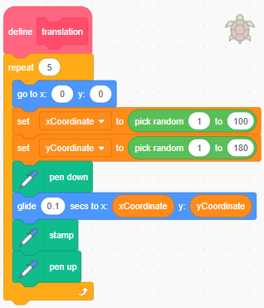
The Transformation Turtle:
Translating with Code and Making Predictions
(cont’d)

Algebra
Unit 3 Line Master 1e

b) Click on the green flag to execute the code.
What do you notice?
c) Alter the random range of the xCoordinate variable to 1 to 150.
d) Before clicking on the green flag to execute the code,
predict what will happen. Explain your prediction.
Was your prediction correct?
3. a) Alter the random range of the yCoordinate variable to 1 to 100.
Your code should look like this:
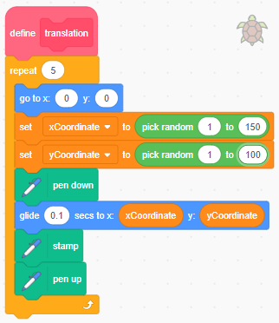
b) Before clicking on the green flag to execute the code,
predict what will happen. Explain your prediction.
Was your prediction correct?

The Transformation Turtle:
Translating with Code and Making Predictions
(cont’d)

Algebra
Unit 3 Line Master 1f

Extension
What else can you change in the code to alter the output?
Experiment with the code and predict what will happen based
on your changes, before clicking on the green flag to execute
the code.

