Answers

Algebra
Unit 3 Line Master 1g

Part 1: Exploring the Code
1. a) 10
b) At (0, 0), which is the centre of the grid; I know because
I can watch it move and also because the code has an
instruction that tells the turtle to go back to x:0 y:0 with
each repeat.
c) Quadrant 1
d) The path the turtle travels.
e) They all slant the same way: up to the right.
2. a) A translation moves a point in a straight line to another point
b) Right; this is controlled by the x-coordinate that is selected,
which is always positive.
c) Up; this is controlled by the y-coordinate that is selected,
which is always positive.

Part 2: Altering the Repeat and the Timing
Sample answers:
1. I think only 5 turtles will be translated; my prediction was correct.
2. I changed the repeat to 15 because I think that the program will
now stamp 15 turtles; I was correct.
3. I think the turtles will move a lot faster; I was correct.

Answers (cont’d)

Algebra
Unit 3 Line Master 1h

Part 3: Altering the x- and y-coordinates within Quadrant 1
Sample answers:
1. Because that is the greatest number along the x-axis of this grid.

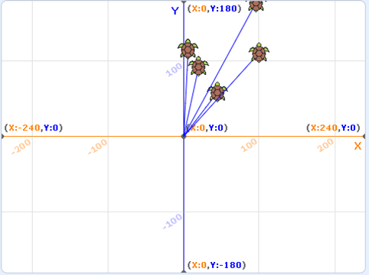
2. b) Only 5 turtles are translated;
they are all in the squares in
Quadrant 1 that are just to the
right of the y-axis.
Sample output stage:

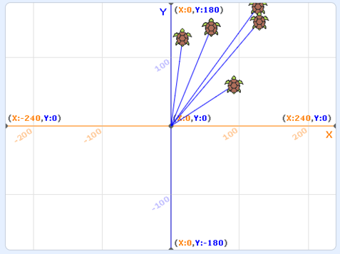
d) I think some of the turtles will
move to points in Quadrant 1
that are farther from the y-axis
but the x-coordinate of the points
will be at most 150.
Sample output stage:

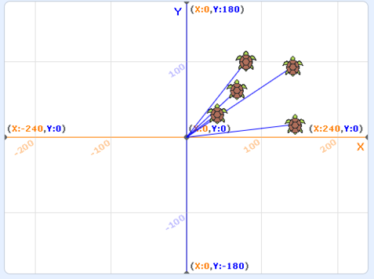
3. b) I think the turtles will move to
points in Quadrant 1 that are
in the squares just above the
x-axis; the y-coordinate of the
points will be at most 100 and
x-coordinates will be at most 150.
Sample output stage:

