Solving Problems Using Equations and Inequalities
Identifies an equation or inequality that represents a scenario  “Raoul can spend up to $40 at the fair. They use $15 for food.  Each ride costs $3. Which inequality shows many rides, r, Raoul can  go on?  • 15 + 3r ≥ 40  • 40 – 3r ≤ 15  • 3r + 15 ≤ 40  The correct inequality is  3r + 15 ≤ 40.  For the first inequality, Raoul would be spending more than $40; for the second, they would have less than $15 for food.” | Solves a given equation or inequality to answer an applied problem  “3r + 15 ≤ 40  I’ll solve the related equation using  a flow chart.  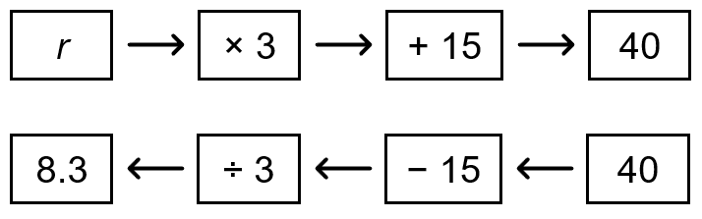  Raoul can’t go on part of a ride. I’ll round down to 8.  Check: If Raoul goes on 8 rides, they spend  3(8) + 15 = 24 + 15 = 39  $39 < $40.  If Raoul goes on even 1 more ride, the cost will be greater than 40. So, my answer is correct.” | Writes and solves an equation to answer an applied problem  A swim team spends $\frac{1}{2}$of their  savings and $250 they raise in a bake sale to buy team swimsuits for $367.50. What were their savings before this purchase?  “I let s represent their savings.  I know $\frac{s}{2}$+ 250 = 367.50  I’ll use a flow chart to solve the equation:  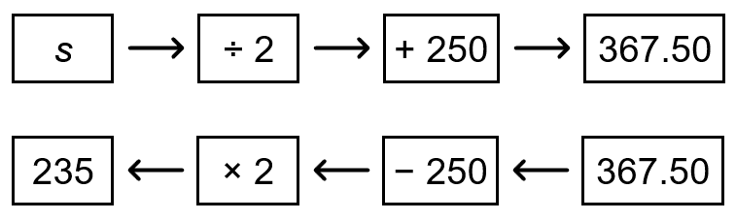  The solution to the equation is  s = 235.  They had $235 in savings.  Check: When s = 235,  $\frac{s}{2}$+ 250 = $\frac{235}{2}$+ 250  = 117.50 + 250  = 367.50.” | Writes and solves an inequality to answer an applied problem.  Toby has $55 to spend to take friends and one of their parents to a movie. An adult ticket costs $12. A student ticket costs $8. What is the maximum number of friends Toby can invite?  “Let n represent the number of student tickets Toby buys. Toby also buys 1 adult ticket.  8n + 12 ≤ 55.  I’ll use a flow chart to solve the related equation:  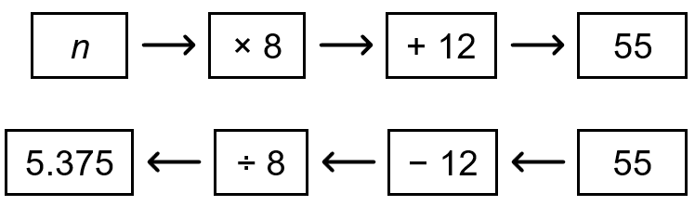  Toby can buy 5 student tickets,  so can invite 4 friends.  Check: When n = 5,  12 + 8n = 12 + 8(5)  = 12 + 40  = 52  $52 < $55  If Toby buys any more tickets,  the cost would be greater than $55.  My answer is correct.”

Observations/Documentation

