Solving and Graphing Integer Inequalities
Determines whether a number is part of the solution for an inequality  “To check whether x = 3 is a solution to the inequality –7x + 4x > –3, I’m going to evaluate –7x + 4x when  x is 3.  –7(3) + 4(3) = –21 + 12  = –9  This is less than the number on the right side of the inequality, so 3 is not part of the solution set.” | Matches an inequality with the graph that shows its solution  “Which of these graphs shows the solution to the inequality 5 – 2x ≤  –3?  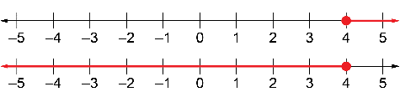  When x = 4,  5 – 2x = 5 – 2(4)  = 5 – 8  = –3  So, x = 4 is the solution to the related equation.  Testing a point on the second graph, when  x = 0, 5 – 2x = 5 – 2(0)  = 5  This is greater than the number on the right side of the inequality, so it is not part of the solution.  The first graph is correct.” | Solves inequalities involving integers  Solve the inequality –3n – 6 ≥ 6.  “For the related equation  –3n – 6 = 6, I can write  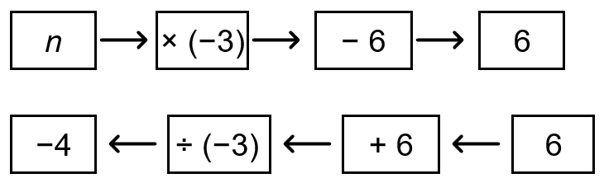  The solution to the equation is  n = –4.  What happens when n is greater than –4, say n = 0?  –3n – 6 = –3(0) – 6  = –6  This is less than 6, so 0 is not part  of the solution set. I know the solution is n ≤ –4.” | Graphs the solution to an inequality involving integers  Graph the solution to the inequality  –3n – 6 ≥ 6.  “For the inequality –3n – 6 ≥ 6, my solution was n ≤ –4. I draw a solid dot at n = –4 because it is part of the solution. I draw a line extending to the left to show that all the numbers less than –4 are also part of the solution.”  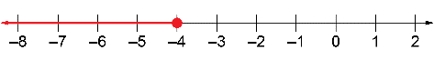
Observations/Documentation

