Solving Equations with Multiple Terms
Solves equations of the form ax + b = c, where a, b, and c are integers or decimals  –3x + 7 = –2  “Using a pan balance and algebra tiles, I determined that x = 3.  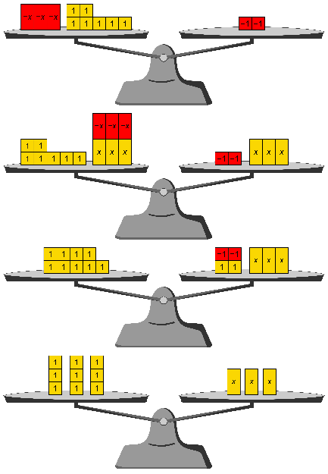  To check, I can substitute 3 for x in the equation.” | Solves equations of the form $\frac{x}{a}$+ b =  c, where a is an integer $≠$ 0, b and c are integers or decimals  “$\frac{x}{3}$– 2 = 5 means that I start with x,  divide by 3, and subtract 2 to get 5.  So, if I add 2 to 5, I’ll find out what  $\frac{x}{3}$ is. Then I can multiply by 3 to  find x.  I can record this with a flow chart.  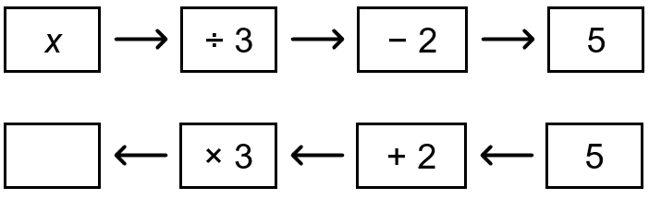  x = 21  I can check by substituting 21 for x in the equation.” | Solves equations that involve multiple terms, integers, and decimals  10.5 + 2.5x = 4.5x – 2.5  “I want the x’s together and the constants together. I’ll subtract 2.5x from both sides and add 2.5 to both sides. I end up with:  10.5 + 2.5 = 4.5x – 2.5x or 13 = 2x  I know that 2 × 6.5 is 13, so x = 6.5.  I will check by substituting 6.5 for x in the original equation.” | Writes and solves equations related to a real-life scenario  Marcus and 3 friends all order the same meal at a fast-food restaurant. Marcus pays for all the meals with a $50 bill and gets $14 in change. Write and solve an equation to determine the cost of each meal.  “My equation to represent this situation is:  4x + 14 = 50  Solving using a flow chart,  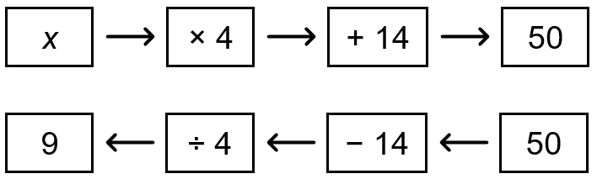  x = 9  Each meal costs $9.  I will check by substituting 9 for x in my equation.”

Observations/Documentation

