Working with Monomials and Binomials
Interprets models of monomials  and binomials  “This design models (5s + 4t).”  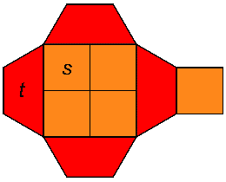 | Determines sums and differences  of monomials with whole-number  or integer coefficients  6s − (−2s)  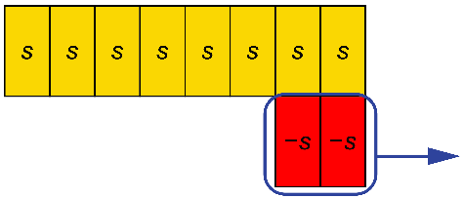  “I modelled 6s. I didn’t have any  −s-tiles to take away, so I added  2 zero pairs. I took away 2 –s-tiles, leaving 8 s-tiles, or 8s.” | Determines sums of binomials with integer coefficients  (–3x + 4y) + (–2x – 3y)  “I need to model 2 different variables and positive and negative coefficients. I’m going to use algebra tiles and two-colour counters. When I combine tiles and counters, and remove zero pairs, I end up with  5 red x-tiles and 1 yellow y-counter. The answer is –5x + y.”  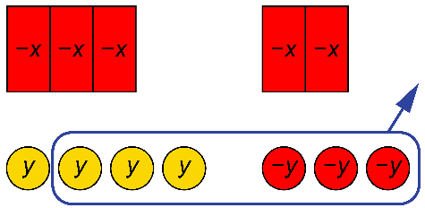 | Solves applied problems involving the addition of binomials  Each side of an equilateral triangle has length (2x + 5) cm.  What is its perimeter?  “The perimeter is the sum of the  side lengths:  (2x + 5) + (2x + 5) + (2x + 5)  I can add the x’s and add the constants.  2x + 2x + 2x + 5 + 5 + 5  = 6x + 15  The perimeter is (6x + 15) cm.
Observations/Documentation

