Algebra
Unit 2 Line Master 5a
Graphing Inequalities

Work with a partner.
Solve each inequality using any method you choose.
Graph each solution on the number line provided.
Show your work.
1. 7s + (–6) – (–s) > 18

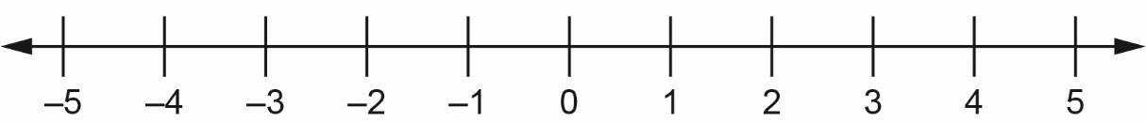

2. –6n + 12 ≥ –9n

3. 3p – 2p – 2 ≤ –4

Algebra
Unit 2 Line Master 5b
Graphing Inequalities (cont’d)

4. 18 – (–9) ≥ –4r – 5r

5. 11 – 8z < –2z – 7

