Algebra
Unit 2 Line Master 4
Inequality Match Up

Three inequalities are shown on the left.
The graphs of three solutions are shown on the right.
Match each inequality with the correct graph.
Explain how you know the solution on the graph you pick is correct.

3x – 3 > 7 + 8x | 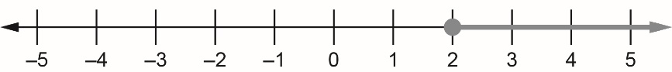
5x + (–3) ≥ 5 + x | 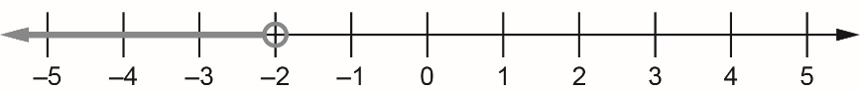
3x – (–7x) ≤ (–2) × (–5) | 